Using a Template with Body and Heading Styles in D2L 10.3
Use these instructions as a guide for using a template to create a new accessible document in D2L. The stylesheet has embedded styles for body text and headings.
- Ensure that you have uploaded the Template.html file to your D2L shell.
  - Create a stylesheet or use a stylesheet that has been provided.
  - In D2L, click on Edit Course > Manage Files.
  - Click on New Folder. Name it Templates.
  - Click on the Templates folder.
  - Click on Upload. Locate the template.html file. Click on Open then click on Save.
- Click on Content.
- Click on New and choose Create a File. Enter an appropriate title.
- Click the Select a Document Template button. Locate the template file. Click the radio button then click on Add.
- Key the content for main title, and choose Heading 1 from the menu: . The heading of the document should display with a style from the stylesheet.
- Enter and key the introductory paragraph.
- Key the level 2 heading and select Heading 2 from the menu.
- For bulleted or numbered lists, click the bullet or number icon from the formatting menu. Return once after each bulleted or numbered item.
- Create tables using D2L’s table features. These steps will apply table headers and a table caption to support screen-readers.
  - Click on the table icon and complete the following information from the General tab. Select the number of columns and rows, alignment, width of the table, and enter “1” if you desire a border. Click the table caption box to create a location for the caption. If you want a colored border or background, click the Advanced tab and select the colors. Click on Insert.
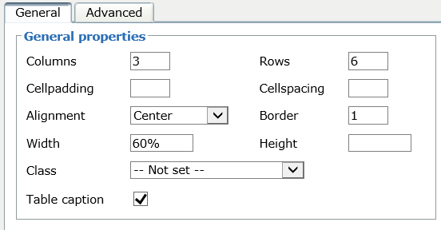
  - Click the line immediately above the table and key the table caption.
  - Key the table items into the appropriate cells. Use the arrow keys to move from one cell to another.
  - Here’s an example of a table described in the following portions of this document.
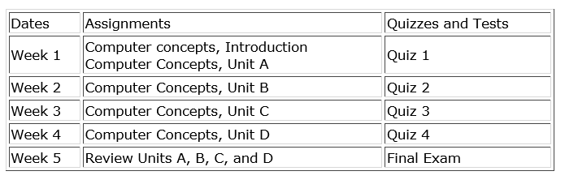
  - Assign headers to the table columns. For assigning headers to the top row, click inside the first cell in the top row titled “Dates.” Click the arrow next to the insert table icon and select Table cell properties.
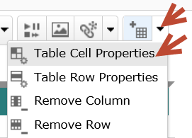
  - On the table cell properties dialog, choose “Header” for Cell type. Choose Column for the Scope, and choose “Update all cells in row” from the dropdown list. The cell headers will be bold and centered.
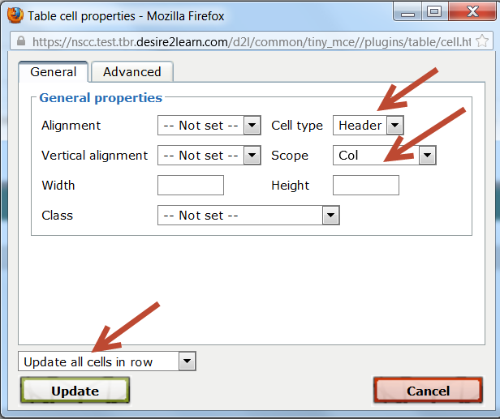
  - The cell headers will be bold and centered.
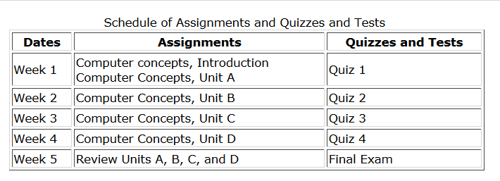
  - For a table that requires headers down the left column, select all cells in the first row except the topmost left cell in the table.
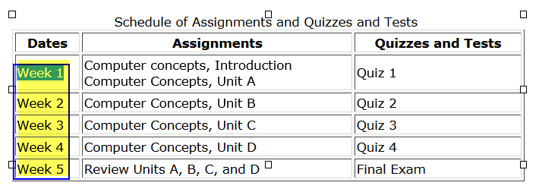
  - Select Table Cell Table Cell Properties. Select Header for the cell type, and Row for the Scope. Click on Update.
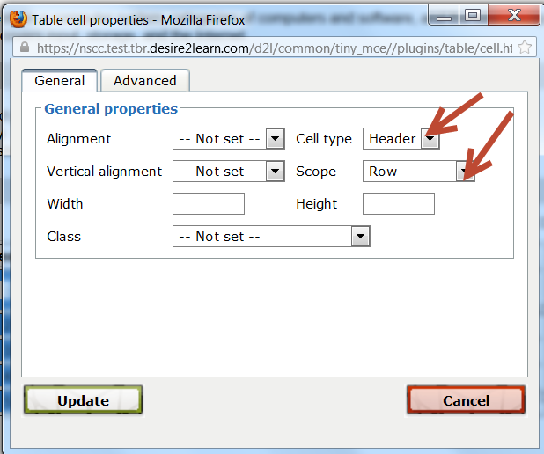
  - The table now will display with bold headings down the left column.
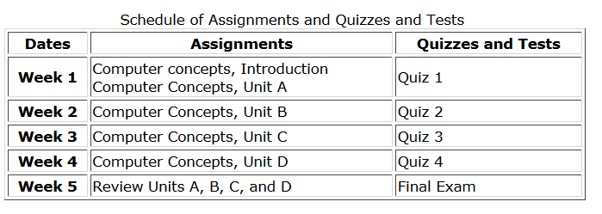
  - When JAWS or a screen reader announces the table, the headers will be read along with the cell contents. For example, Column 2 and Row 2 will read “Assignments, Week 1, Computer Concepts Introduction, Computer Concepts, Unit A.

