Changing the Navigation in D2L 10

Enter the course for which you want the navigation bar changed. Click on the gear icon immediately below “My Home” or click on “Edit Course.”
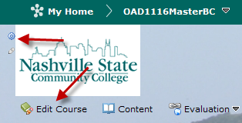

If you click on “Edit Course,” the following screen displays. Click on “Navigation and Themes.”

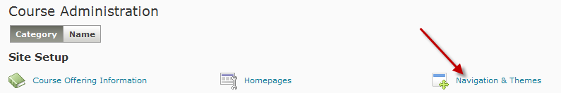

The following screen displays:

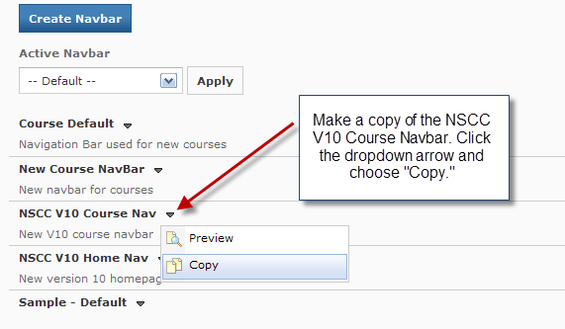
” NSCC V10 Home Nav – Copy” now displays in the list of navbars. Click on the title to make changes.
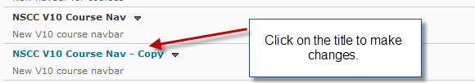

Create a Custom Link
To create a link to a website, click the “Create Custom Link” button.
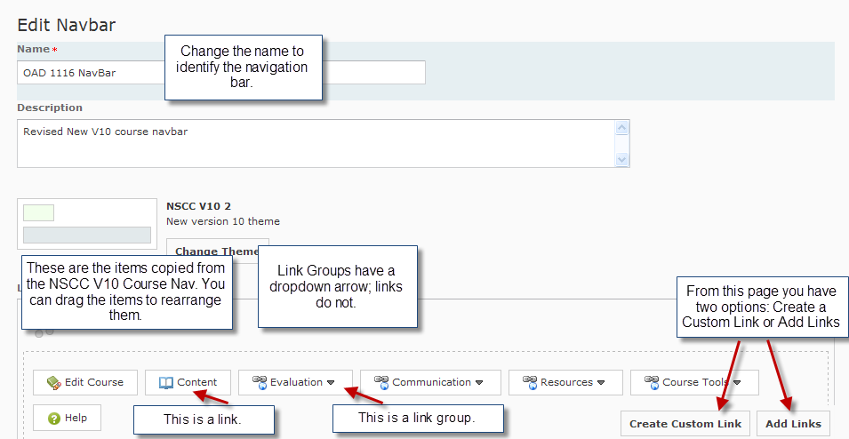
Complete the requested information. Click on “Create” at the lower left of the screen.
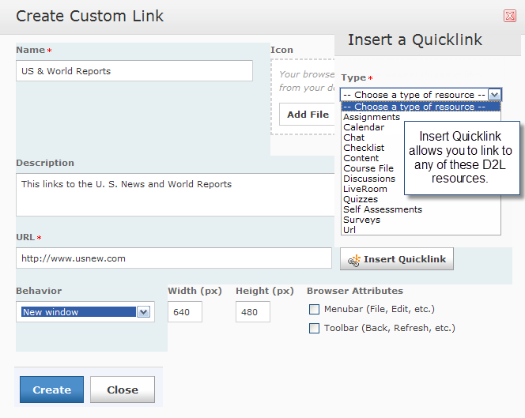

The link is added to the navigation bar. Click on Save and Close.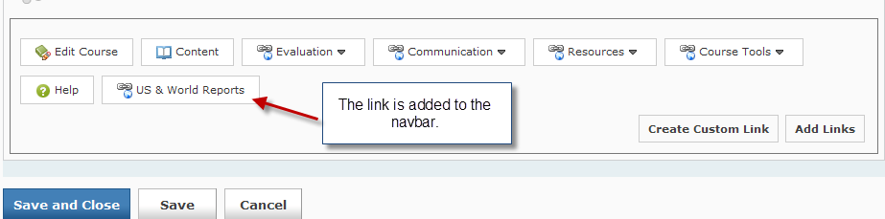

Edit a Link Group
To add or remove an item from a group list, click on the “Navbars” tab at the upper left of the screen.
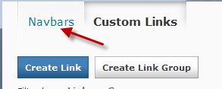
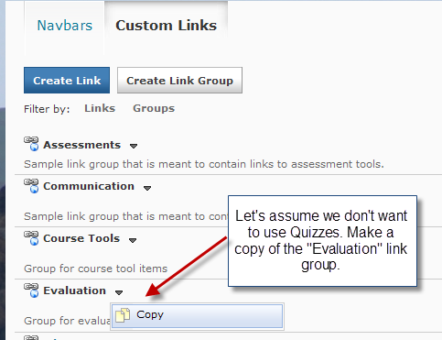
You now have a new Evaluation link group without Quizzes. Note that there are two groups named Evaluation, so we have to be careful to use the new one that was created.
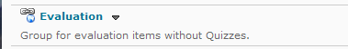

Name the link group. Remove items that you do not want to display on the dropdown menu. Click on Save. This returns you to the screen where you have two tabs: NavBars and Custom Links.
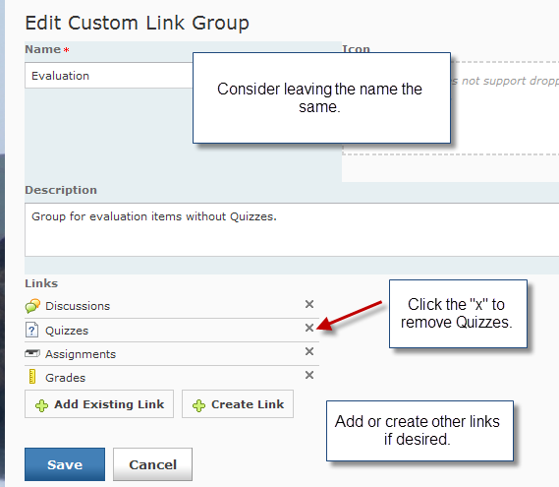
Click on NavBars. Click on the name of the navbar that you are designing. Click on Add Links then choose the group that you created. Click the Add button.
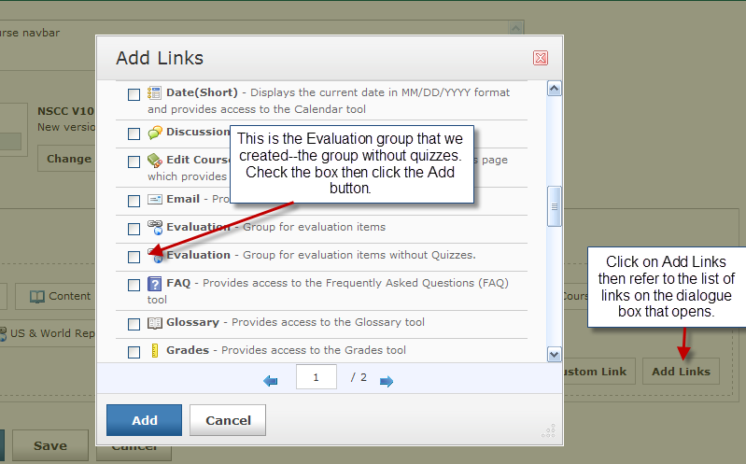
Click the “X” to remove the old Evaluation group and drag the button for the new Evaluation group to the original location. Click on Save and Close.
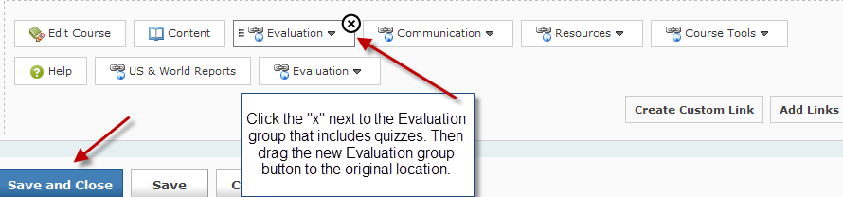
Click on the Active Navbar from the dropdown list and click on Apply.
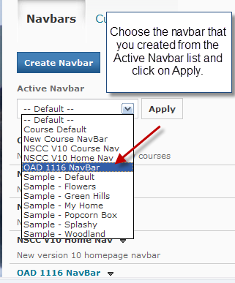
Your new navigation is now in your course.
