How to Install Respondus Lockdown Browser on a PC

Respondus Lockdown Browser (RLB) may be required for taking an online test. The steps for installing RLB are as follows:
- Unless RLB has been installed on the computer previously, the start the test with a browser of choice.
- The following screen displays. Click on “Download Respondus LockDown Browser.”
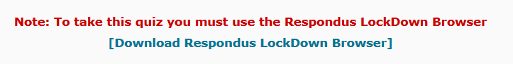
- Choose Windows or Mac.
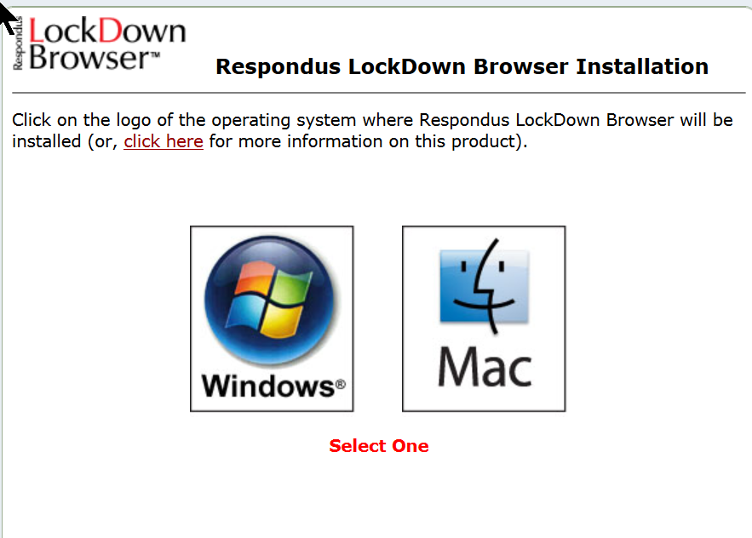
- Three options are provided. Lab computers may require installation privileges. If so, contact technical support. Work computers may not permit installation of software. Install RLB on “Your Own Computer” if you have installation privileges.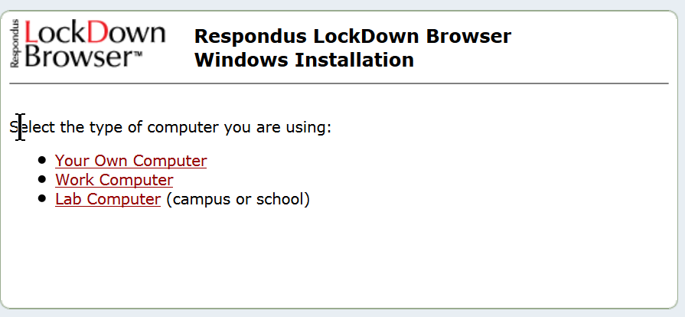
- If you are installing on your own computer or a computer where you have installation privileges, click on one of the links to download LockdownFXS.exe.
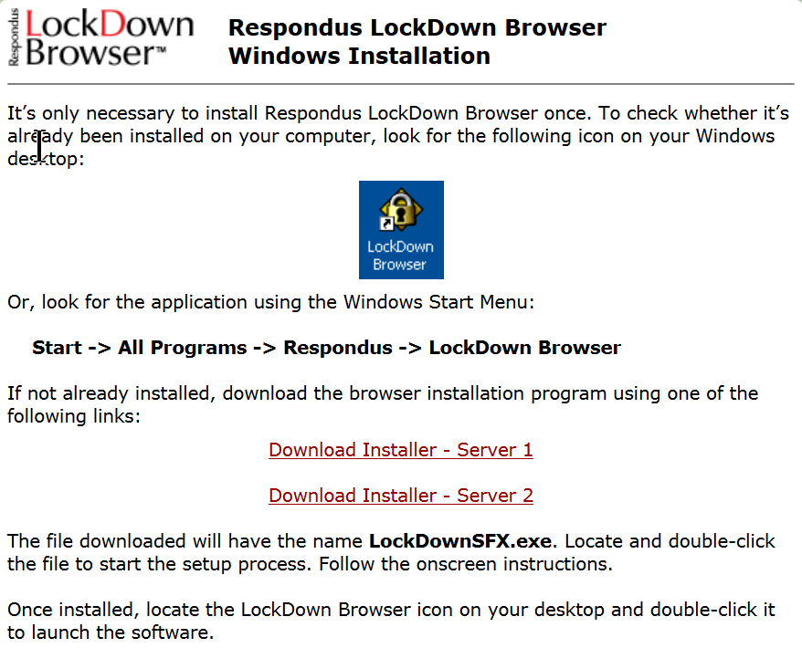
- Save LockDownSFX.exe to a location where you can find it.
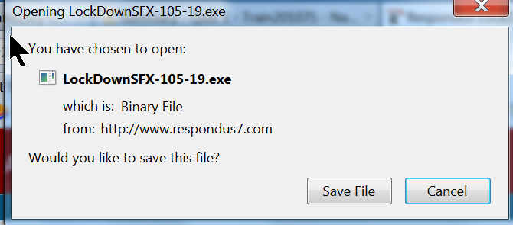
- Double-click on LockDownSFX.exe to start the installation.
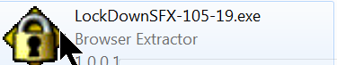
- Click on Run.
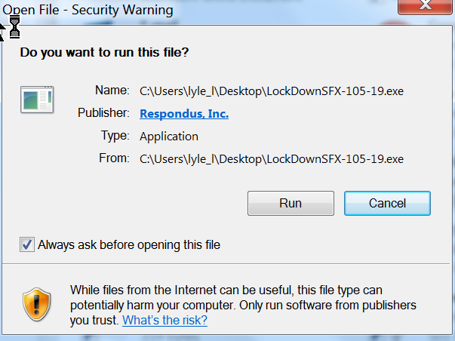
- “Click to Install” to begin the installation process. Follow the prompts to complete the installation.
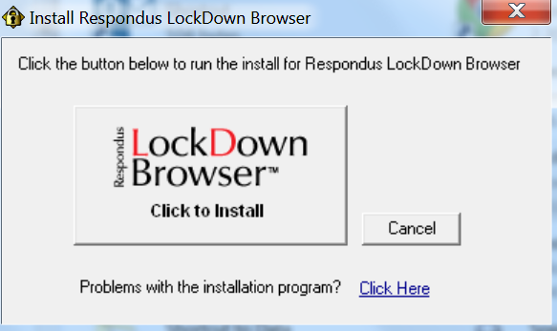
- The student should close all programs on the computer and click on the Respondus Lockdown Browser icon. RLB is a browser. The student will logon and navigate to the test following the standard logon procedure.

