News Items in D2L

Beginning of Term
At the beginning of the term, you may want to post three news items to help students get started.
- Item 1—Include course information such as the name and section number of the course, instructor’s name and phone number, image of book cover (if desired).
- Item 2—Course Description. This item can be set to display for the first week or two of the semester so students will be aware of the description and any prerequisites.
- Item 3—Getting Started instructions.
Here are some News Examples: http://ww2.nscc.edu/lyle_l/sample_documents/news.htm

During the Term
The News section is also a good place to send announcements during the semester. If you plan to make class announcement in the News section, tell students to check the news items on a regular basis.

How to Create and Edit News Items in D2L

Create a News item:
- Enter the course by clicking on the title of the course.
- Locate the News widget in the right column.
- From the News action arrow, click on “New News Item.”
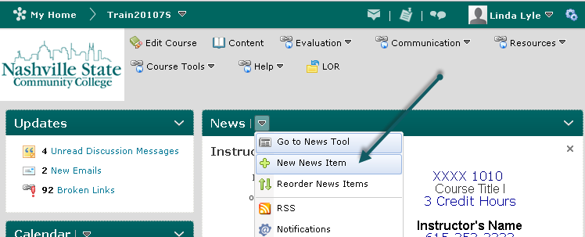
- Type a headline and add content.
- Set start and end dates as desired.
- Attach a file or record audio (1 min. or less) if desired.
- Click on Publish to release the news item or Save as Draft to publish it later.

Edit a News Item:
- Enter the course by clicking on the title of the course.
- Click on the Action Arrow for News, and select the Edit option.
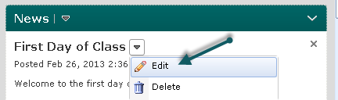

- Make editing changes.
- Determine whether this is a major edit, which means you want to send another copy to students who have RSS feeds or Notifications set so they will be notified when a new item is displayed.
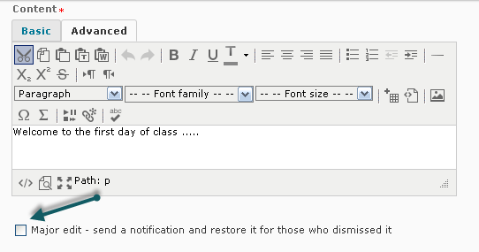
- Click on Update.

To dismiss a News item, click the "X" in the upper right corner of the News textbox. This does not delete the item; it only removes it from the display.

To restore a News Item, select "Go to News Tool" from the News action menu. Locate the News item. Click the actions menu for the individual news item and select "Restore." Click on the course title on the minibar to view the restored news.

