Overview of the Classlist

View Information on the Classlist
Refer to the image below and the numbered list to locate information on the classlist.

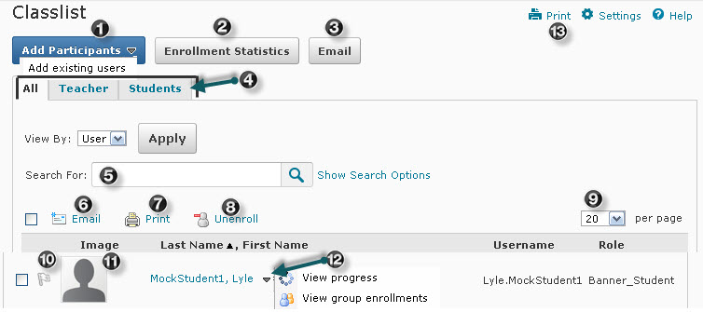

Locate the following items on the image above:
- Add participants is an option faculty can use to add students to their D2L courses that display on the MyNSCC (Banner) role but do not display on the classlist in D2L.
- Enrollment Statistics provides enrollment statistics and grades for students who have withdrawn from the course.
- Email button used to email all users for the selected tab (all, teachers, students).
- All, Teacher, or Students tabs to display specific types of users.
- Search after selecting specific search criteria.
- Email icon to email selected users.
- Print icon to print a list of select users.
- Unenroll selected students.
- Display up to 200 users per page.
- Flag students as a reminder to follow up.
- Image student uploaded in the student profile.
- Action arrow next to each student's name to view progress of users for assignments, quizzes, discussions, and other course content and to view group enrollments if groups have been set up in the course.
- Print tab to print a list of all users whose names appear on the tab list.

