Creating a Paragraph Quiz Using Fill-in-the-Blank Questions

- Select Quizzes from the Evaluation group.
- Click on New Quiz and enter a name.
- Click on Add/Edit Questions.
- Click on New and select Fill-in-the-Blank Questions.
- Key the instructions in the first text box. Return to separate the instructions from the beginning paragraph. Key the beginning paragraph including the options for keying text in the blanks.
- In Blank # 1, enter the correct answer.
- Notice that you can change the size of the box based on the length of the expected answer.
- In the weight box, determine the percentage by the number of answers in the entire paragraph. For example, if there are 10 items the students will enter, then each box get 10 percent. Select whether or not you want the answer to be case sensitive.
- In the next text box, enter the next section of the paragraph up to the point where students are to make another choice.
- Scroll back toward the top of the screen until you see the Add Blank box. Click on Add Blank. Key the answer.
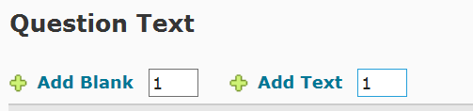
- Continue the process: add the next text, add the next blank, and continue the process until the paragraph question is completed.
- Save.
- See the example on the next page.
