RSS Feeds in Firefox 9.0.1
When you subscribe to a feed, the content is automatically downloaded from NS Online (hereinafter referred to as D2L) news so the feed is up to date. One option for subscribing to D2L feeds is to use Firefox.

A couple of things to keep in mind is that you need to subscribe separately to the news for each course. Also, use your “A number” as the user name and your six-digit birthdate mmddyy as the password.

To set up the RSS feed for Firefox, use Live Bookmarks. Click to start Firefox then Download the “Feed Sidebar” Add-On.

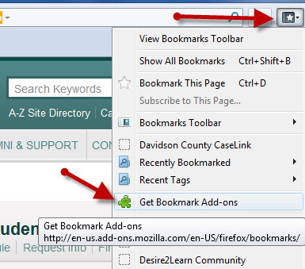
- Click on the “Display your bookmarks” icon at the top right of the screen. Choose “Get Bookmark Add-ons.”
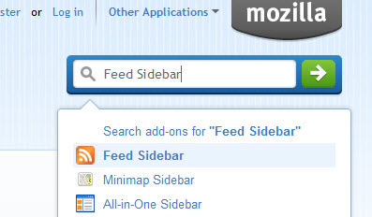
- Enter “Feed Sidebar” in the search box and choose Feed Sidebar.
- Click on Add to Firefox. Follow the steps to install. It adds the RSS icon. Click the RSS icon to toggle the feed window on or off.
To set up the feed,
- Go to the D2L course.
- From the action menu for News, click on the RSS icon in the News widget as shown in the illustration below.
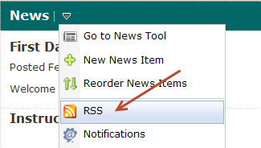
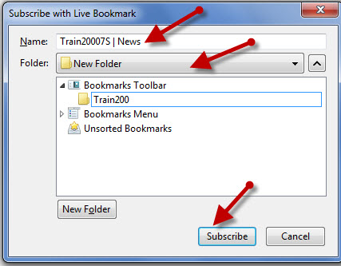
- Click on “New Folder” and enter a name. Click on Subscribe.

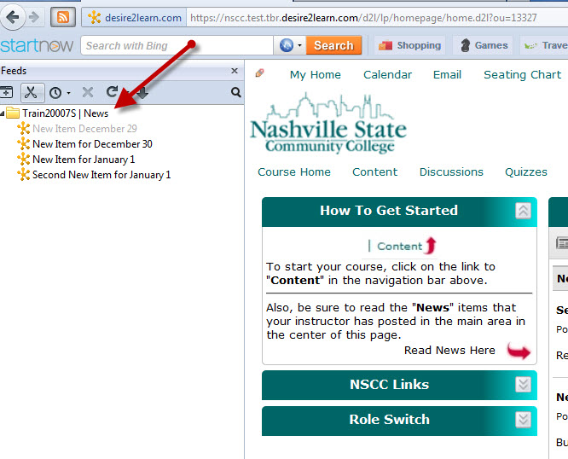
- The feed will be available by clicking the RSS icon at the top left of the screen in Firefox.

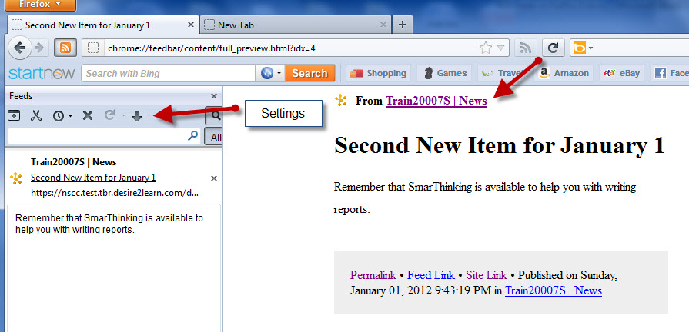
- Click on a specific item to display it in the window on the right.
- Click on the link with the course name to go to a login page to enter the D2L course. Use your “A number” as the username and six-digit birthdate mmddyy as the password.

NOTE: Settings in Firefox Feeds are available to:
- Open all in tabs.
- Mark all as read.
- Limit the age of the items shown.
- Cancel feed.
- Reload Feeds.
- Sort by…
- Show both read and unread items.

