ACCT 2840
Lesson 6A Exercises
Instructions
Exercises are based on cases from the Adamski text. Some have been modified by the instructor.

Pine Hill Music School
- Download the database named Pinehill 6 and save it to your working disk. Open Pinehill 6.

- Add a Combo Box to the Contract table.
  - Open the Contract table in Design view.
  - Add a Combo box Lookup field to the LessonType field. (Be sure you have completed the mini-tutorial on How to Add a Combo Box to a Table).
  - The Row Source Type is a Value List.
  - The Row Source items to be listed in the value list are as follows:
Cello; Flute; Guitar; Piano; Percussion; Saxophone; Voice; Violin
  - Set the Limit To List property to Yes.
  - Save your changes and close the table.

- Create a custom form called frmContract.
  - Create a new form in Design View. Save your design changes often so you don’t lose any work.
  - Add the following fields from the Contract table to the Detail section of the form:
ContractID, Contract Start Date, Contract End Date, Lesson Type, Lesson Length, Monthly Lesson Cost, Monthly Rental Cost, StudentID, TeacherID
  - Place the ContractID and ContractStartDate on the same row at the ½ inch mark as shown in the example at the bottom of the page.
  - Place the ContractEndDate underneath ContractStartDate.
  - Leave the LessonType, LessonLength, MonthlyLessonCost, and MonthlyRentalCost fields in a column underneath the Contract ID field but place them with the LessonType field starting at the 1 ¼ inch mark.
  - Delete the Student ID and TeacherID fields.
  - Add a StudentID combo box to the form. See pages 336-338 of your text for refresher
    - Place the combo box underneath ContractID.
    - From the Student Table, select the LastName, FirstName, and StudentID fields, in that order.
    - Sort in ascending order by the LastName field and then by the FirstName field.
    - Store the results in the Student ID field and label the field Student ID.
  - Add a TeacherID combo box to the form. See pages 336-338 of your text for refresher instructions.
    - Place the Teacher ID combo box beside the LessonType field and aligned underneath ContractEndDate.
    - From the Teacher Table, select the LastName, FirstName, and TeacherID fields, in that order; and sort in ascending order by the LastName field and then by the FirstName field.
    - Store the results in the TeacherID field and label the field Teacher ID
  - Add a title to the Form reads “Student Contracts”. Make the label Arial 18 point in dark red and bold.
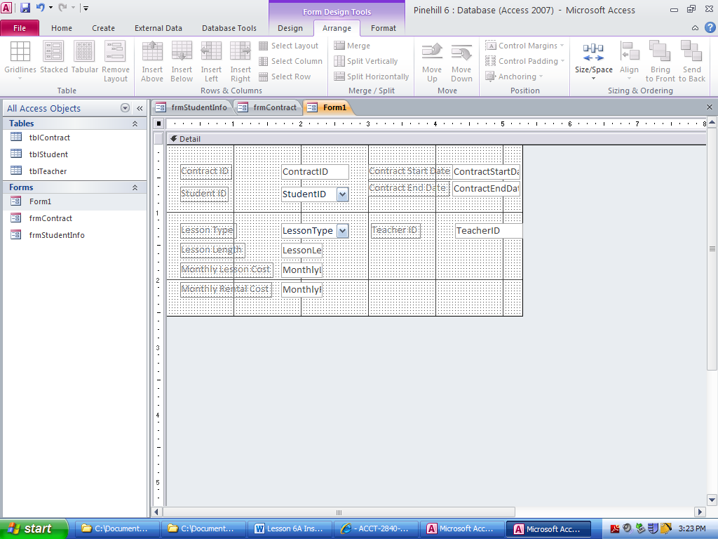
- Pine Hill Music School has new students complete an information form. See the attached page. This form is used by the Pine Hill administrative staff to enter student information into the company database. A form called StudentInfo was created by a staff member using the AutoForm feature to store the data entered on the Student Information Form.
  - Print the attached paper copy of the student information form which has been filled out by a potential student. Attempt to enter the data on the paper form using the Access StudentInfo form.
  - Make the following adjustments:
    - First adjust the Student table. This is the record source for the StudentInfo form. Make sure the table has all fields indicated on the paper form except for “What instrument are you interested in?”. (This information will be used for another form.) Add the fields needed to complete the table applying appropriate field types and sizes.
    - Next, adjust the StudentInfo form and insert the new fields just added in the table.
  - Make sure that the layout of the form essentially matches the paper form so that new records can be easily entered.

5. Pine Hill also allows clients to complete applications online. The same StudentInfo form is used by parents/students completing the application online.
- Make design changes on the StudentInfo form so that it is attractive. (Your grade will be based in part on the effort you apply to formatting this form.)
- Add instructions to the form so that users who are not familiar with Access understand how to navigate the form (do not worry about web accessibility at this time.)

6. Use the paper form to try to enter the new student data again. If you still find that the design does not work well from a data entry viewpoint, continue to make adjustments.

7. Make sure all your changes are saved and close the Pinehill database.



Pinehill Music School
Student Information Form

Student ID Smi5222 (to be completed by school staff)

Name

Smith Caroline G.
Last First Middle Initial

Gender M F

Address

123 Disney Avenue
Number & Street

Hillsboro OR 97214
City State Zip Code

Phone

503-555-1212 503-555-8951
Home Cell

Birthdate 6-22-02

Program
What instrument are you interested in? Piano

Will you be renting an instrument? Yes No

Parkhurst Health & Fitness Center
1. Download the Fitness 6 database and save it to your working disk. Open the Fitness 6 database.

2. Create a custom form named frmStaff.
a. Create a new form in Design View. Save your design changes often so you don’t lose any work.
b. Place all fields from the Staff table in the Detail section of the form as shown below. Arrange, align, and size the fields to approximately match the example. Adjust the size of the text boxes so that the data displays appropriately.
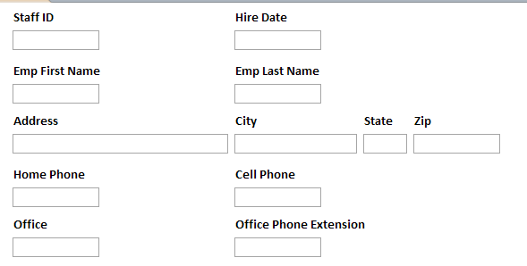
c. Add a title to the form that reads “Parkhurst Health & Fitness Center Staff”.
d. Add an image of barbells to the title using the following steps.
i. Open PowerPoint.
ii. Select the Insert tab and click Clip Art.
iii. In the Search for: text box enter barbells. If no results display, make sure the Include Office.com content checkbox is checked and search again.
iv. Click on a barbell graphic of your choice to add it to a blank PowerPoint slide.
v. Right-click the graphic on your PowerPoint slide and choose Save as picture. Specify the name Barbells and set the Save as type to JPEG. Select your working drive for the Save in location.
vi. Close PowerPoint without saving your changes.
vii. Return to Access. Make sure you are in the Staff form in Design view.
viii. From the Design tab, click the Logo button in the Header/Footer group.
ix. Navigate to the drive containing your files for this course and select the Barbells file.
x. Size the graphic as you see fit.

3. The MembershipStatus field in the Member table has a Combo Value List with Active and Inactive listed as values. Edit the MembershipStatus field in the Member Table to include On Hold as an option on the Value List and make sure that no entries other than those defined in the list will be accepted by the database.

4. Create a custom form in design view named frmMembershipApp.
a. See the application form on the next page which was created in MS Word. This form is filled out in hard copy by Parkhurst Health & Fitness Center’s clients. You will be creating a database form object to match the layout of this hard copy paper form.
b. Before you can design your form, you must alter the table design to make sure that all fields required on the paper form are found in the table. Add any necessary fields to the Member Table. Use you prior knowledge to name the new fields and apply appropriate field properties.
i. The date shown on the application form is the date the client joined the club.
c. Create a form in Access that approximates the layout of this form. Design the form so that data entry personnel can easily enter data from the hard copy form into Access. NOTE: You are not trying to create a form to be printed from Access—you should create an Access form that approximates the layout of the paper form but that interacts with your database.
d. You should also add a field found in tblMember for Membership Status. The default status for all new clients is Active.
- e. Although you are following the basic layout of the hard copy form, apply formatting as you see fit. Add any labels you feel make the form easy to understand and use. (Your grade will be based in part on the effort you apply to formatting this form.)

8. Close the Fitness database.

Submit the following files to the Lesson 6A Exercises folder in NS Online Assignments:
Pinehill 6.accdb
Fitness 6.accdb

Parkhurst Health & Fitness Center
Client Application Form

Member ID ______________ (to be completed by club staff)

Date ____________________

Name

____________________ ____________________ ____________________
Last First Middle

Address

______________________________________________________
Number & Street

______________________________________________________
City State Zip Code

Phone

____________________ ____________________ ____________________
Home Work Cell

Birthdate ____________________

