Create a Template Using Blue Griffon

Blue Griffon was chosen as the HTML editor because it inserts HTML5 and CSS3 code. The template, as described below, includes styles for body, heading 1 and heading 2. Many other options are available, but the template includes only basic embedded styles. When you open the template file, it appears blank. You will add your own text making sure you do not select fonts.
- Install Blue Griffon (free). http://bluegriffon.org/pages/Download Two options are available: download the installer or download a zip file. If you don’t have installation privileges, download the zip file then unzip it. Click on the bluegriffon.exe file to start the program. The program is free, but there is a charge for the user’s manual and for any add-on that you choose.
- Start Blue Griffon.
- Click the arrow to the right of the New icon. Click on “more options.” When the dialog opens, select HTML 5 and choose English/United States as the language and select UTF-8 as the character set. Click on Save.
- Choose Format on the top menu then choose Page Properties. Enter the page title.

Set the Body Styles
- Click the Set CSS Styles icon to open a Style Properties window to the right of the screen. Click on the body tag at the lower left of the screen. You should see <body> selected at the top of the Style Properties dialog.
- On the Style Properties dialog, next to “Apply styles to:” select “all elements of same type.” Set the following:
  - General: Click the “+” symbol for Font Family, then select Arial, Helvetica, sans-serif (or desired font).
  - Geometry: Copy the information from the illustration below. Uncheck the “Same four paddings” and “Same four margins” check boxes. Enter the values as shown below or enter the values you desire: Max width (750px), Padding left and right (10px), and left and right margins (auto.)
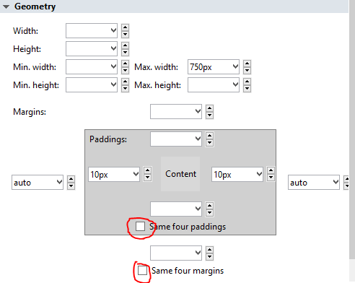

Set the Heading 1 Tags
- Choose Heading 1 at the top left of the screen (see illustration below), then click on the H1 tag at the lower left of the screen.
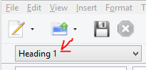
- Verify that <h1> and “all elements of same type” are selected on the Style Properties dialog. Set the following:
  - General: For Alignment, choose Center.
  - Color: Choose background and enter #197c7C in the “Hex” textbox or select the desired color. Choose White for the foreground color (this is the text color).
  - Borders: Use same border on four edges. Enter 6px as the thickness and choose Inset for the style.
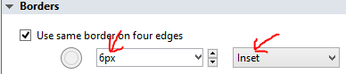

Set the Heading 2 Tags
- On the main screen touch the Enter key to create a new line then select Heading 2 from the top left of the screen. Click on the Heading 2 tag at the lower left corner of the screen.
- Verify that <h2> and “all elements of same type” are selected on the Style Properties dialog. Set the following:
  - Colors: Click on the background color button.
  - Enter #d8d8d8 in the “Hex” box or select the desired shade of gray.
- Click on File and Save. The html file is now ready to upload to a folder named Template in a D2L shell.

Upload the Template to D2L
- In D2L, click on Edit Course > Manage Files.
- Click on New Folder. Name it Templates.
- Click on the Templates folder.
- Click on Upload. Locate the template.html file. Click on Open then click on Save.

