Embedding YouTube Videos in Desire2Learn
(Two Methods)

by Linda Lyle
Nashville State Community College
120 White Bridge Road
Nashville, TN 37209
615-353-3432
linda.lyle@nscc.edu

Method I
- Go to your D2L Course.
- Add a module if one does not already exist.
- Add a topic and create a new file or edit an existing file to which you want to add the video.
- Click on “Add Topic.”

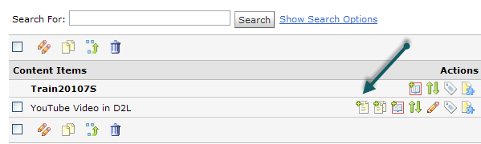

- Click on “Create New File.”

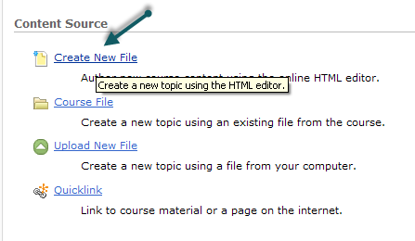

- Type a title.
- Click on the Advanced tab of the HTML editor.
- Click the Insert Stuff button.

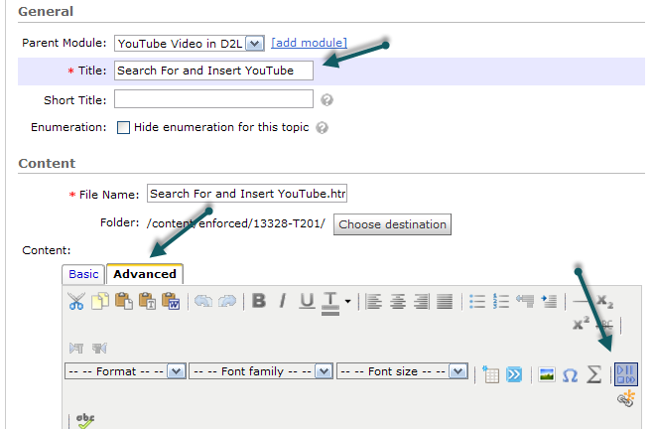

- Click on YouTube.
- Enter a search term to locate a video.
- Select the video.
- Click on Next.

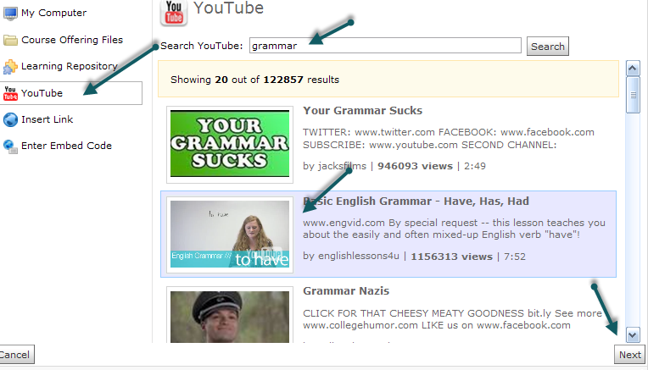

- Click on Insert.
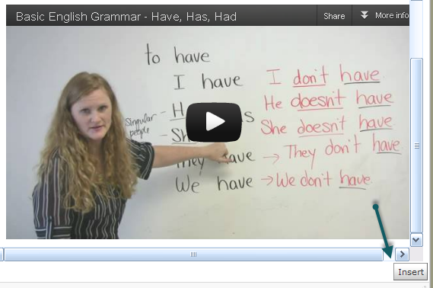

- Click on Save.

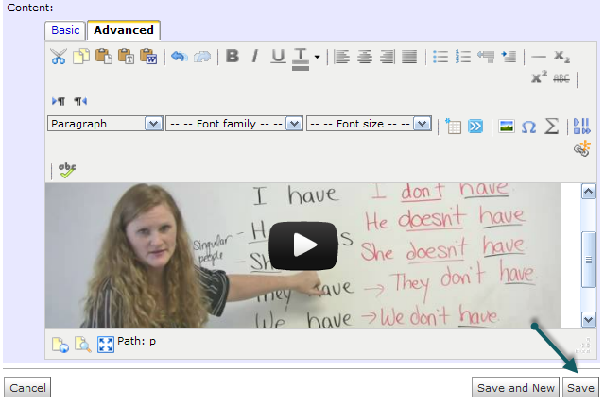

To view the video as a student,

- Click on View Content.
- Click on the link that leads to the video.
- Click the play button to view the video as a student.
- “Some” YouTube videos provide auto closed captioning. View it by clicking the CC icon.—it’s not very accurate.

Method II
- Go to www.youtube.com or other site and locate the video that you want.
- Below the video click on the Share button, click on the Embed button to display the embed code.
- Select the size of the video to embed.
- Copy the code. Right-click and select Copy or use the keystroke combination Ctrl+C.
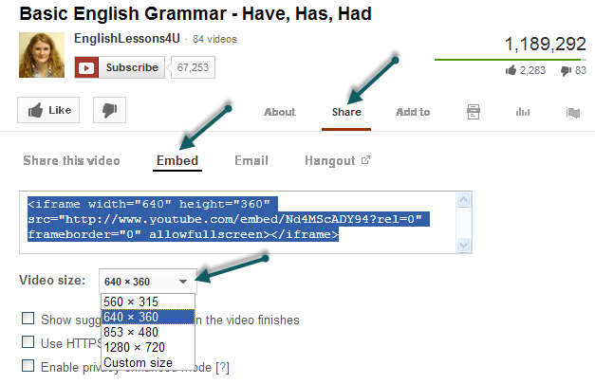
- Go to your D2L Course.
- Add a module if one does not already exist.
- Click on “Add Topic” to create a new file or edit an existing file to which you want to add the video.

- Click on Create New File.

- Type a title.
- Click on the Advanced tab of the HTML editor.
- Click the Insert Stuff button.

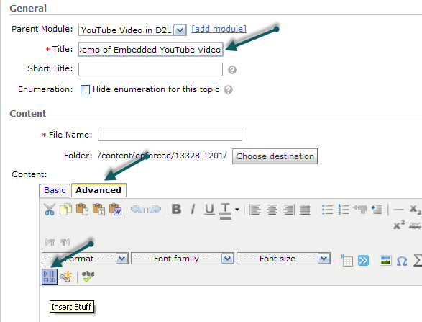

- Select the Enter Embed Code option in the left window.
- Paste the code in the Embed Code box.
- Click on Next.

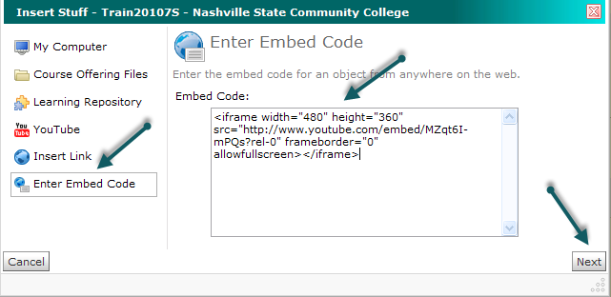
- Preview the video.
- Click on Insert.

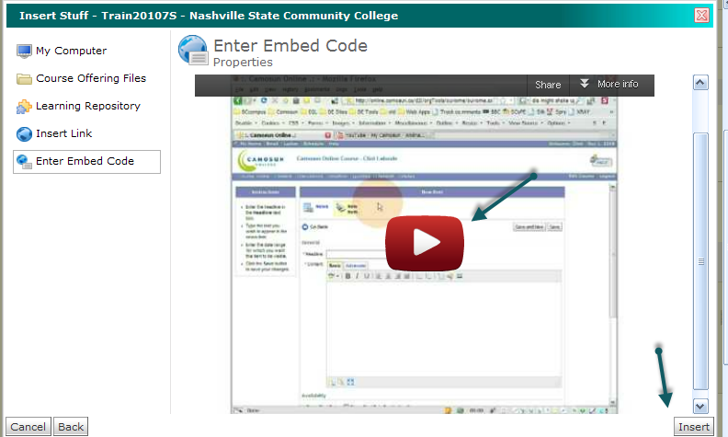

- At the next screen, click on Save.

To view the video as a student,
- Click on View Content.
- Click the link that leads to the video.
- Click the play button to view the video as a student.
- “Some” YouTube videos provide auto captioning—it’s not very accurate. See the illustration below.



