Changing the Navigation in D2L 10

Create and/or Add a Custom Link to the NavBar

Enter the course for which you want the navigation bar changed. Click on the gear icon immediately below “My Home” or click on “Edit Course.”
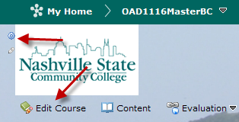

If you click on “Edit Course,” the following screen displays. Click on “Navigation and Themes.”

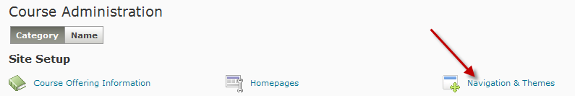

The following screen displays. Make a copy of the NSCC V10 Course NavSlim Navbar. Click the dropdown arrow and choose “copy.”

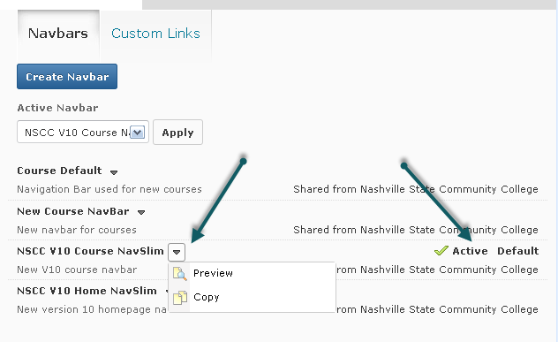
”NSCC V10 Course NavSlim – Copy” now displays in the list of navbars. Click on the title to make changes.

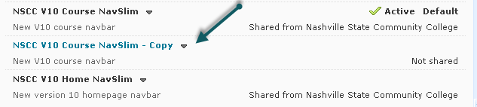

Click on Create Custom Link.

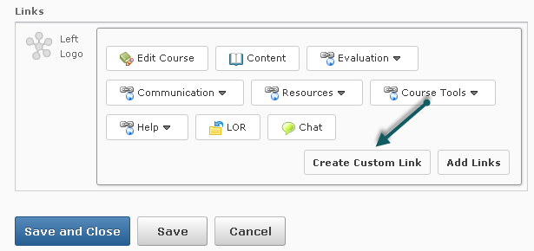

Choose to upload a file (see supported file types on the screenshot below) or choose to link to a URL.

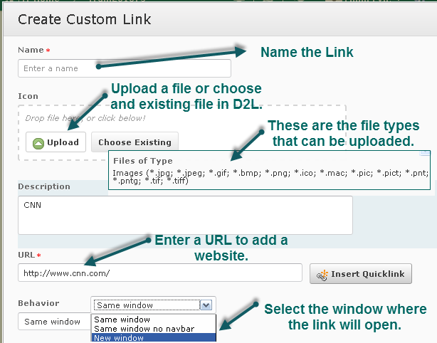

Click on Create.

Click on Add Link and locate the link. The click on Add.

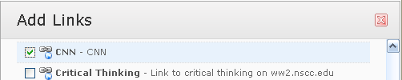

The custom link is added to the Navbar. Drag and drop to reorder the links.

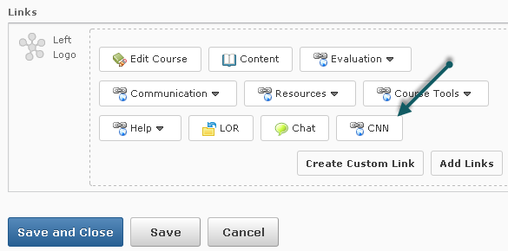

Enter a meaningful name and description. Click on Save and Close.

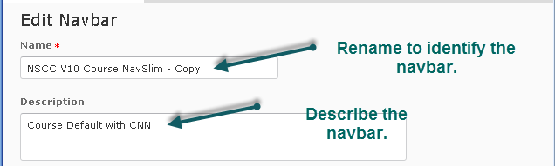

Make the Navbar active by selecting it from the Active Navbar list and clicking on Apply. The new custom link will display on your course navigation bar.

