RSS Feeds and Google Reader
When you subscribe to a feed, the content is automatically downloaded from NS Online (hereinafter referred to as D2L) news so the feed is up to date. One option for subscribing to D2L feeds is to use Google Reader.

A couple of things to keep in mind is that you need to subscribe separately to the news for each course. Also, use your “A number” as the user name and your six-digit birthdate mmddyy as the password.

To set up the RSS feed for Google Reader,
- Click to open the browser of choice.
- Go to the D2L course.
- From the action menu for News, click on the RSS icon in the News widget as shown in the illustration below.
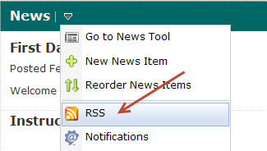

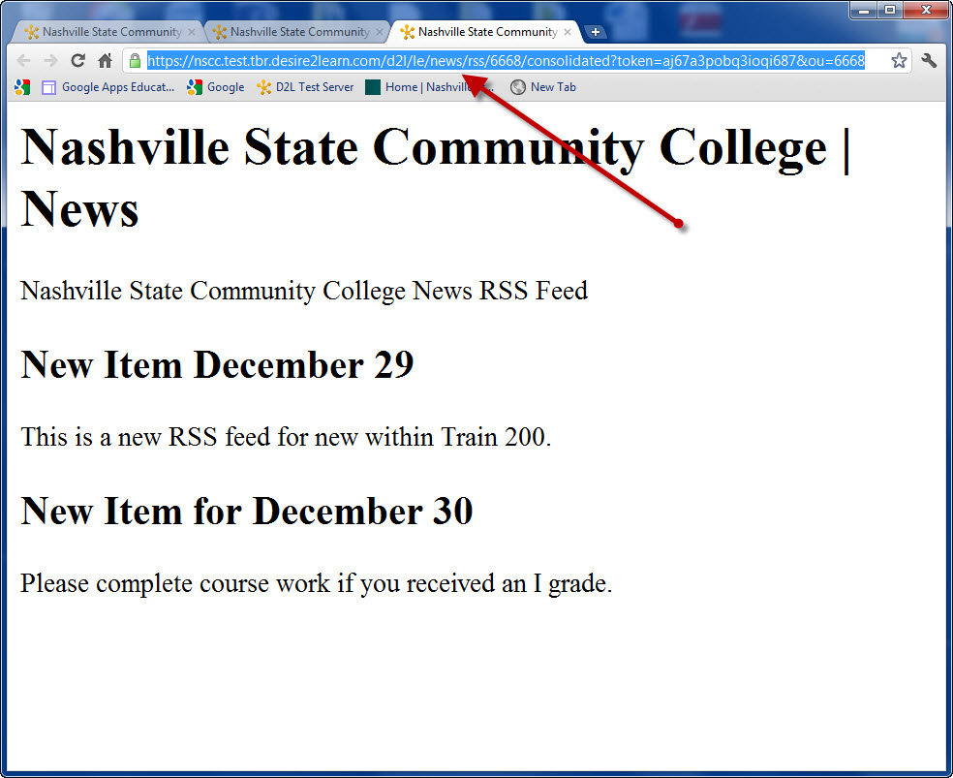
- Copy the URL from the screen that displays.
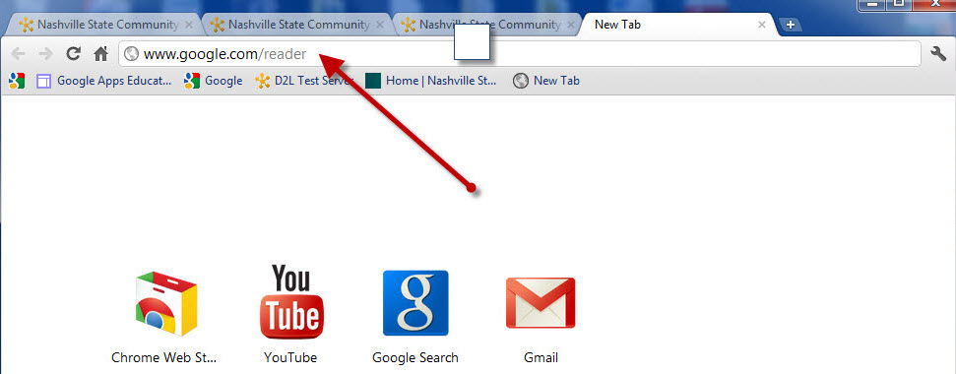

- Go to www.google.com/reader. Set up a free account if you do not already have a Google account.
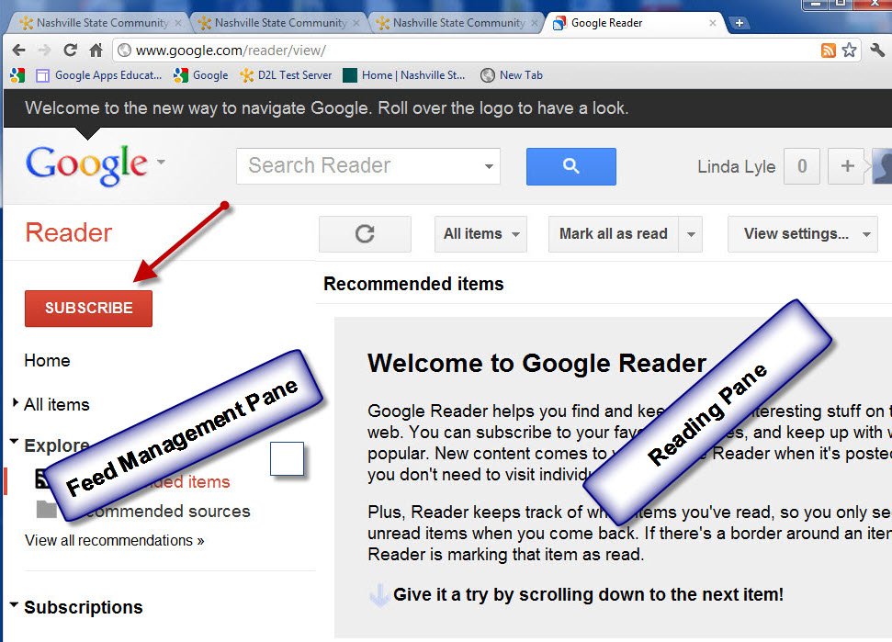
- There are two panes: the Feed Management Pane on the left and the Reading Pane on the right. To subscribe, click on Subscribe.
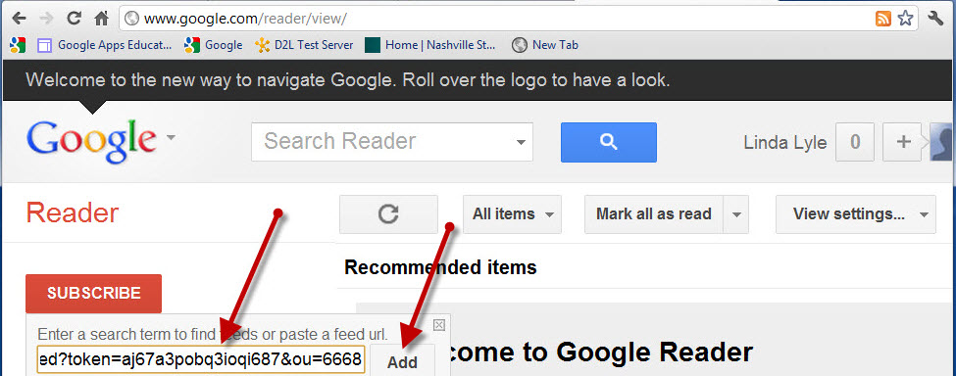
- Paste the URL copied from the course news feed.
- Click on Add.

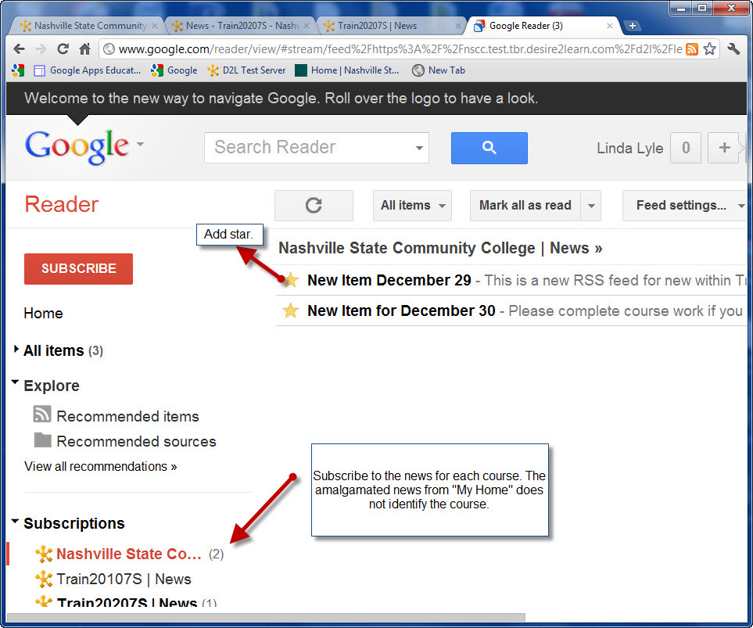
- The news feed will be added to the Subscriptions list in the Feed Management Pane. The number in parentheses indicates the number of unread items.
- Repeat the process for each course.
To read the feeds, click on the course name under Subscriptions. Click the “Add Star” button to retain the article after reading it.
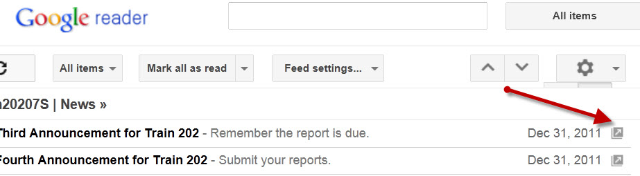
To view the article as it appears in D2L, click the arrow at the end of the feed title.
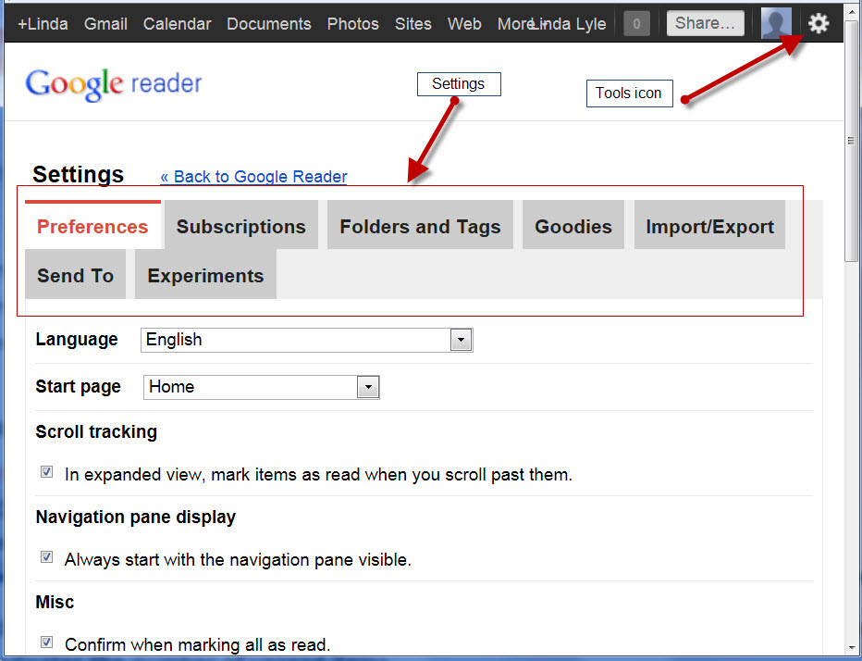
In Google Reader, click on the tools icon and choose Reader Settings to set preferences, to view subscriptions, and to manage folders and tags.

