RSS Feeds in Internet Explorer 9
When you subscribe to a feed, the content is automatically downloaded from NS Online (hereinafter referred to as D2L) news so the feed is up to date. One way to subscribe to D2L feeds is to subscribe directly from Internet Explorer.

A couple of things to keep in mind is that you need to subscribe separately to the news for each course. Also, use your “A number” as the user name and your six-digit birthdate mmddyy as the password.
- Click to open Internet Explorer 9. If the command bar is not visible, right-click the Favorites button and select Command Bar.
- Logon to D2L. Go to a course to subscribe to the news for that course.
- From the action menu for News, click on the RSS link as shown in the image below to subscribe.
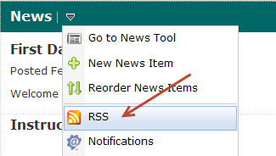
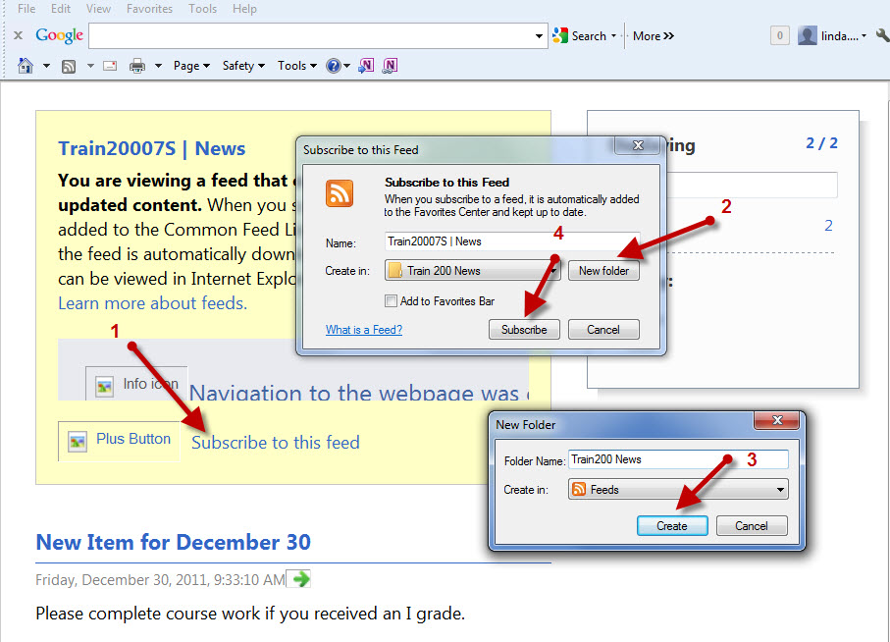
- Refer to the image above and click on “Subscribe to this feed” (No. 1).
- Create a “New folder.” Use the course name as the folder name (No. 2).
- Click on “Create” (No. 3).
- Click on “Subscribe” (No. 4).
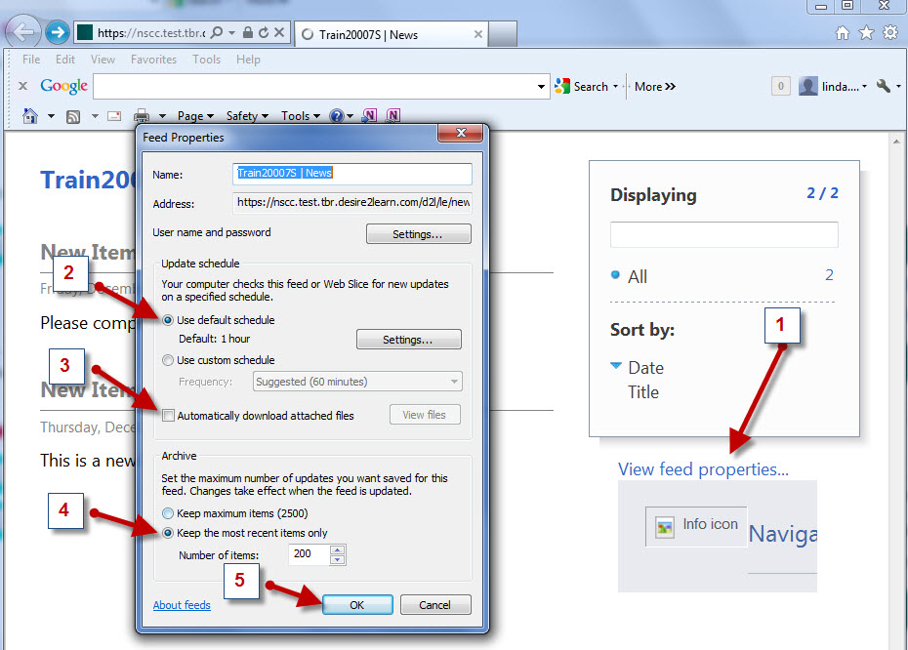

- Refer to the image above and click on “View feed properties (No. 1).”
- Choose options for “Update schedule” to choose how often the feed should be updated (No. 2).
- Choose “Automatically download attached files” if desired (No. 3).
- Enter a number of items to be archived (No. 4)
- Click on “OK” (No. 5).
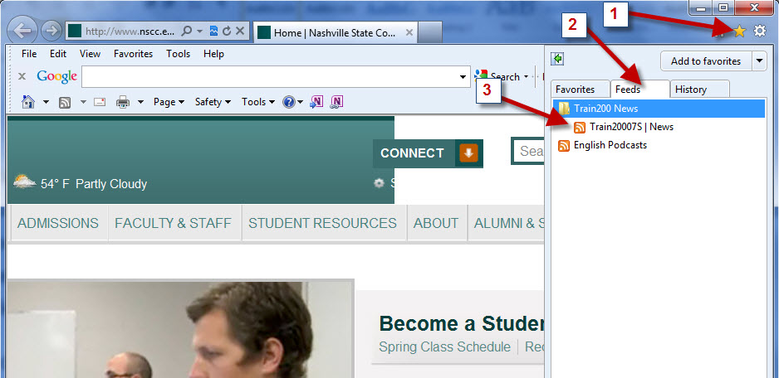

To view feeds,
- Click on the Favorites star on the Command Bar. If the command bar is not visible, right-click the Favorites button and select Command Bar.
- Click the Feeds tab.
- Click the title of the course feed.
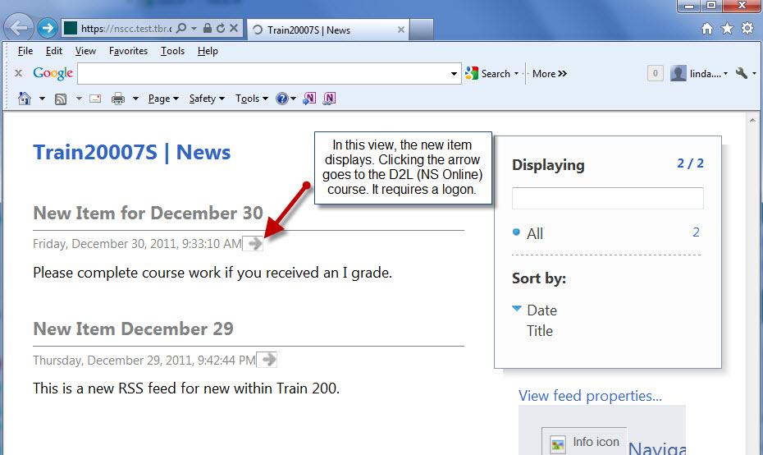
The RSS feed displays as shown in the image above. The complete news announcement displays. Please note that if you click the arrow to view the full article, you must enter your “A number” and six-digit password mmddyy to logon to the course.

