Convert Word With SoftChalk Then Paste to a Template in D2L

Use these instructions as a guide for stripping the Word specific code from a Word file with SoftChalk then pasting the HTML code to D2L. Use a template in D2L to control styles. The stylesheet has embedded code to control body text, headings, etc. To complete these steps, you will need SoftChalk, a template file for D2L, and a Word file that you wish to convert to HTML.

Install SoftChalk
Nashville State faculty and adjunct faculty may install SoftChalk on their computers. To obtain a copy of SoftChalk and install it on your computer, go to Public Folders in NSCC email. Go to Public Folders, select All Public Folders, then click the arrow next to the Instructional Services Folder. Click on Other Materials and click on the SoftChalk 8 item. Download and installation instructions are provided along with licensing information.
The advantage of using SoftChalk is that it strips the Word specific code from a Word document then the code can be copied and pasted to an HTML file.

Upload Template to Desire2Learn
- In D2L, click on Edit Course > Manage Files.
- Click on New Folder. Name it Templates.
- Click on the Templates folder.
- Click on Upload. Locate the template.html file. Click on Open then click on Save.

Copy Content From Microsoft Word
To begin the conversion process,
- Open the document you wish to convert in Word.
- Select all content. (Control + A; Control + C) or use the Select and Copy options.

Paste to Then Copy from SoftChalk
- Launch SoftChalk.
- On a new page, click on Edit then select Paste or use the keystroke Control + V.
- Click on Tools and select HTML source.
- Select and copy all of the text between <body> and </body>.

Create a New File Using the Template in Desire2Learn
- Go to Desire2Learn.
- From the Content area, click on New and choose Create a File.
- Name the file then select a template. NOTE: If you fail to name the file first, you may not be able to save the file after selecting a template.
- Click on Update.
- Select Edit HTML.
- Click on the HTML Source Editor icon </> at the lower right corner of the editor.
- Paste the content (Control + V) you copied from SoftChalk between the <body> </body> tags.
- Close the HTML editor window. You may want to update at this point so you don’t lose the content you pasted.
- If you chose to Update at this point, click on Edit HTML and use the following guidelines for editing the content.

Edit the Document in Desire2Learn
- Assign Heading levels: Heading 1 to the title, Heading 2 to secondary levels, Heading 3, etc. Each heading must be on a separate line.
- Remove extra lines.
- Select lines for bulleted or numbers lists. Use the bullet or number icon. Remove additional characters that appear before each numbered or bulleted item.
- Tables should have been created. Click inside the table and click on the table icon and verify that Table captions is checked.
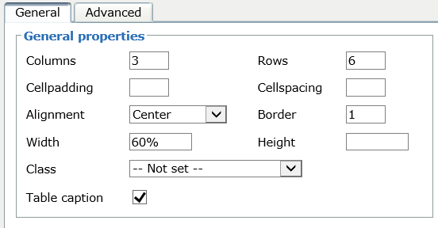
- Click the line immediately above the table and key the table caption.
- Use the arrow keys to move from one cell to another.
- Here’s an example of a table.
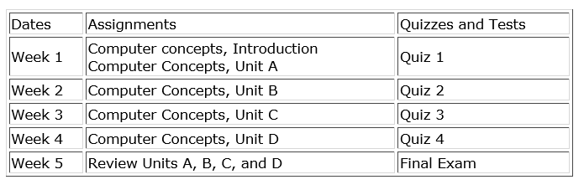
- Assign headers to the table columns. For assigning headers to the top row, click inside the first cell in the top row titled “Dates.” Click the arrow next to the insert table icon and select Table cell properties.
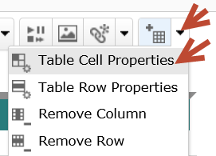
- On the table cell properties dialog, choose “Header” for Cell type. Choose Column for the Scope, and choose “Update all cells in row” from the dropdown list. The cell headers will be bold and centered.
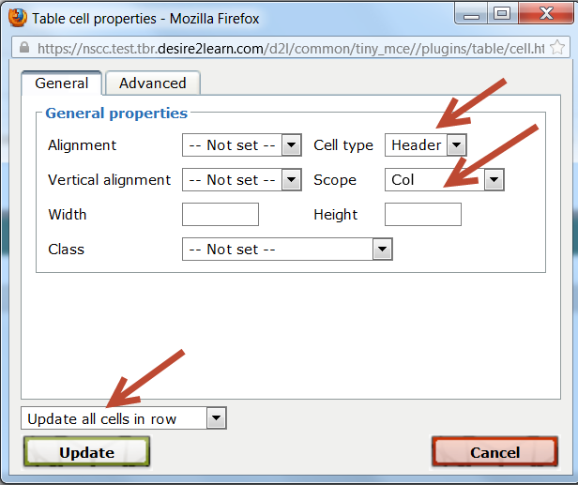
- The cell headers will be bold and centered.
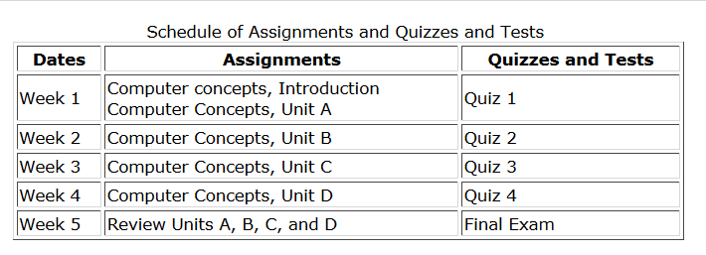
- For a table that requires headers down the left column, select all cells in the first row except the topmost left cell in the table.
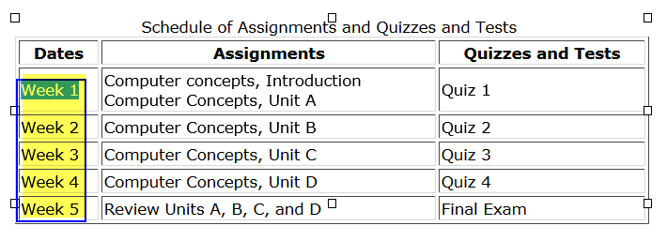
- Select Table Cell Table Cell Properties. Select Header for the cell type, and Row for the Scope. Click on Update.
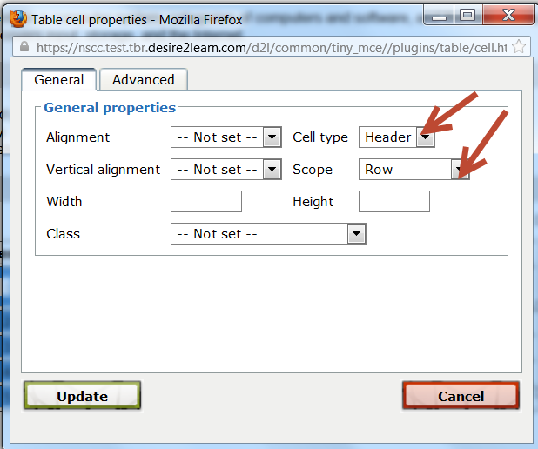
- The table now will display with bold headings down the left column.
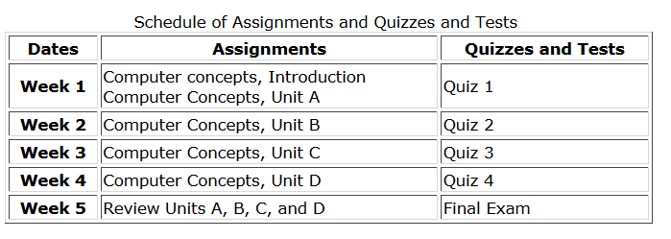
- When JAWS or a screen reader announces the table, the headers will be read along with the cell contents. For example, Column 2 and Row 2 will read “Assignments, Week 1, Computer Concepts Introduction, Computer Concepts, Unit A.
- You should now have an accessible HTML file that can be easily updated by any instructor who has a copy of your course.

