Changing the Navigation in D2L 10

Add an Existing (System) Link to the NavBar

Enter the course for which you want the navigation bar changed. Click on the gear icon immediately below “My Home” or click on “Edit Course.”

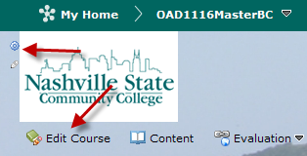

If you click on “Edit Course,” the following screen displays. Click on “Navigation and Themes.”

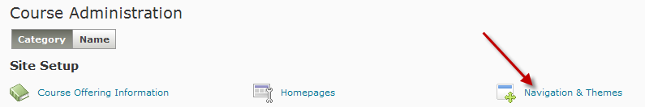

The following screen displays. The NSCC V10 Course NavSlim is the Active Default navbar. Make a copy of the NSCC V10 Course NavSlim Navbar. Click the dropdown arrow and choose “copy.”

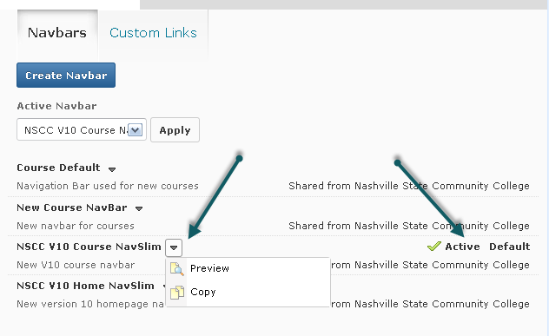

”NSCC V10 Course NavSlim – Copy” now displays in the list of navbars. Click on the title to make changes.

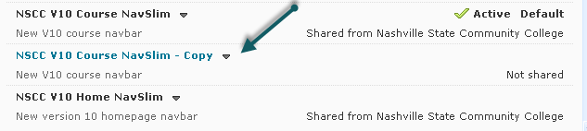

Click on Add Links.

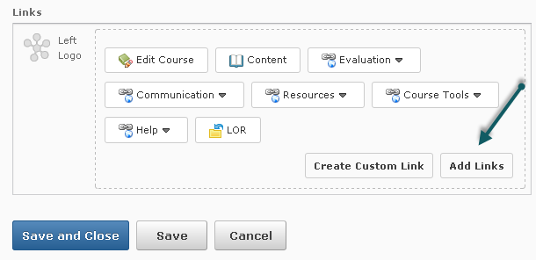

From the Add Links dialogue screen, click on System Links and check the box next to the link you wish to add. Click on Add.

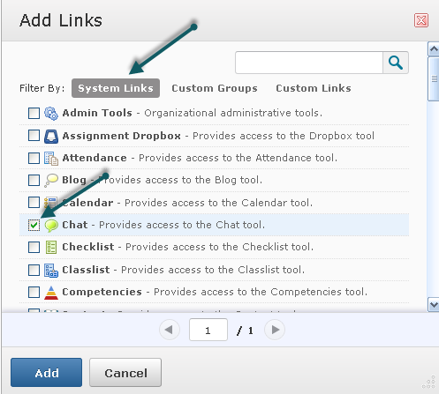

The new link will be added to the navbar. Drag and drop to reorder the links.

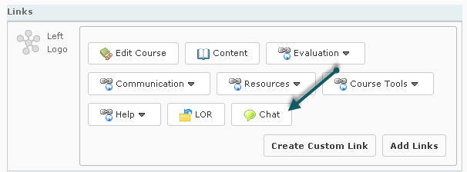

Change the name from NSCC V10 Course NavSlim – Copy to a meaningful name and edit the description.

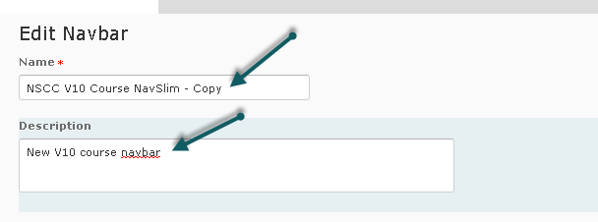

Click on Save and Close.

Select the new navbar and click on Apply. Your new navbar becomes the Active navbar.

