Changing the Navigation in D2L 10

Move or Delete Navigation Links

Enter the course for which you want the navigation bar changed. Click on the gear icon immediately below “My Home” or click on “Edit Course.”
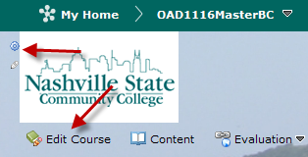

If you click on “Edit Course,” the following screen displays. Click on “Navigation and Themes.”

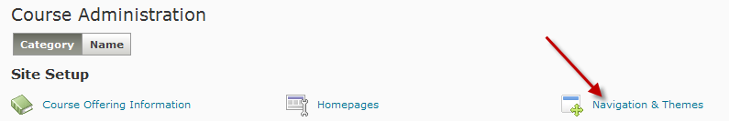

The following screen displays:

The following screen displays. The NSCC V10 Course NavSlim is the Active Default navbar. Make a copy of the NSCC V10 Course NavSlim Navbar. Click the dropdown arrow and choose “copy.”

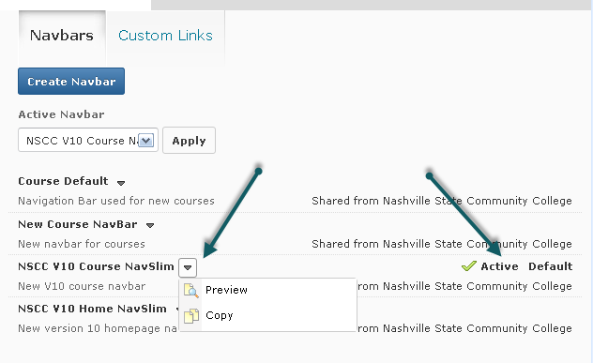

”NSCC V10 Course NavSlim – Copy” now displays in the list of navbars. Click on the title to make changes.

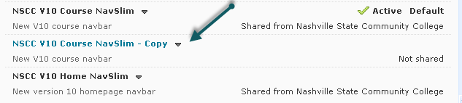

Read the descriptions on the image below to understand the “Edit Navbar” screen.

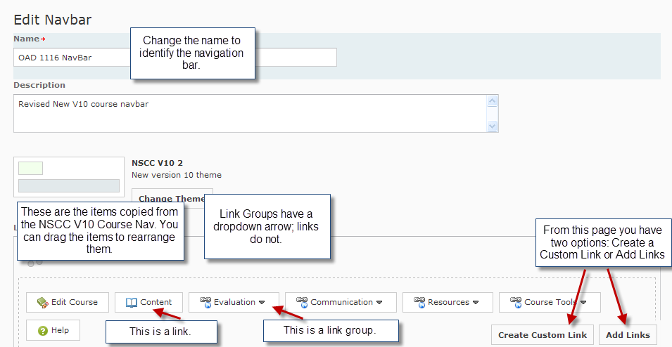

To rearrange links, drag and drop the items to the desired location. To delete a link, move the cursor over an item and click on the X. Click on Save and Close.
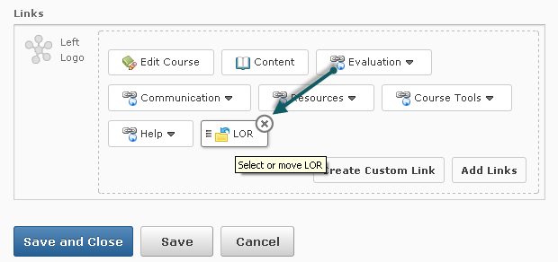

Change the name from NSCC V10 Course NavSlim – Copy to a meaningful name and edit the description.

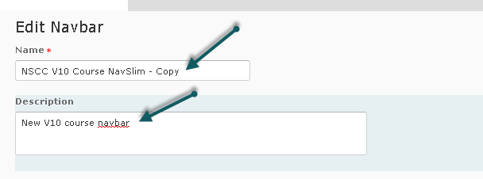

Click on Save and Close.

Select the new navbar and click on Apply. Your new navbar becomes the Active navbar.

