Understanding the HTML Editor in D2L
In D2L, you can create a new HTML file or edit an HTML file using the built-in editor.
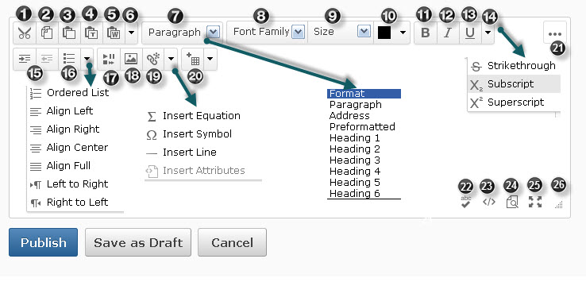
In the illustration above, note the following features and explanations:
- Cut
- Copy
- Paste
- Paste as Plain Text
- Paste from Word: Used to paste copied content from Word. Otherwise much of the formatting will be lost. For example, there will be no paragraph divisions once you save the file.
- Undo and Redo
- Select Heading level styles or Paragraph style
- Select Font Family, such as Arial or Verdana
- Select Font Size
- Select Text Color
- Bold
- Italic
- Underline
- Select Strikethrough, Superscript, or Subscript
- Indent or Outdent
Click the dropdown list next to No. 16 to choose alignment: Ordered List; Left, Center, Right, or Full Alignment; Move paragraph left to right or right to left.
- Unordered (bulleted) List
- Insert Stuff. Most often used to insert embed code or links to video or audio files. Often used to insert YouTube videos.
- Insert Image
- Insert Quicklink. Used to insert URLs or links to any of the course elements such as specific quizzes or assignments.
The dropdown arrow next to No. 19 inserts equations (built-in equation editor used for math equations), symbols (special characters such as ©, ®), horizontal lines, or HTML attributes (HTML code and is most likely beyond the scope of the average user.)
- Insert New Table. The dropdown arrow next to New Table lists table formatting options.
- Show or Hide available options in the HTML editor
- Check Spelling
- View and Edit HTML Source Code
- View Document
- Display the Editor Full Screen. This option provides more space for editing and viewing the document.
- Drag to increase or decrease the size of the editor screen
The Publish button saves the document and makes it available for viewing. Draft saves a copy but does not display the document to users. Cancel disregards changes made to the document.

