Video Note
Video note is available in D2L. In order to record a video, you will need a webcam with sound. The recording can be up to three-minutes and can be inserted anywhere in D2L that you use the HTML editor: Content, News, Discussions, Assignments, etc.
Recording a video requires Flash—it is best to have the latest version.
To record a video note:
- Enter the D2L course. Click on the tool for which you want to create the video note. For example, click on Content.
- Choose “New, Create a File.”
- Key a title or headline and any other text content as desired.
- Click on “Insert Stuff.”
- Select “Video Note” from the menu at the left.
- A new dialog box opens. You may need to click on Flash settings below the video display window. Select “Allow” then click the camera icon to ensure that your video camera is selected. Click on “Close.”
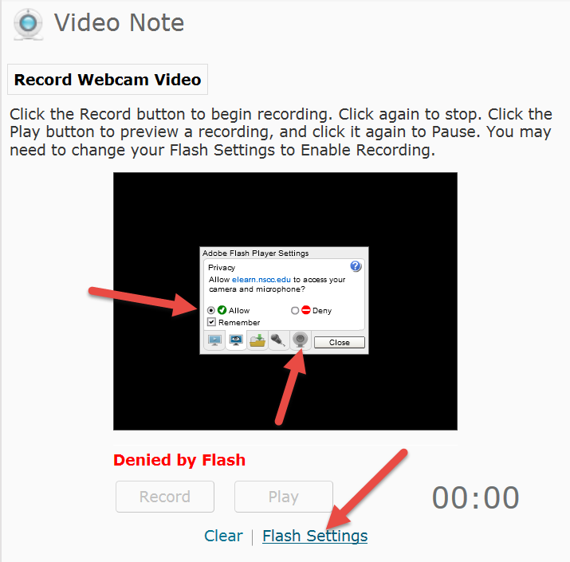
- At this point, it may be necessary to close the Video Note screen and click on Insert Stuff again.
NOTE: I found that if I click on Insert Stuff and wait a while before clicking on Video Note, the image will display. I believe it takes a while to process.
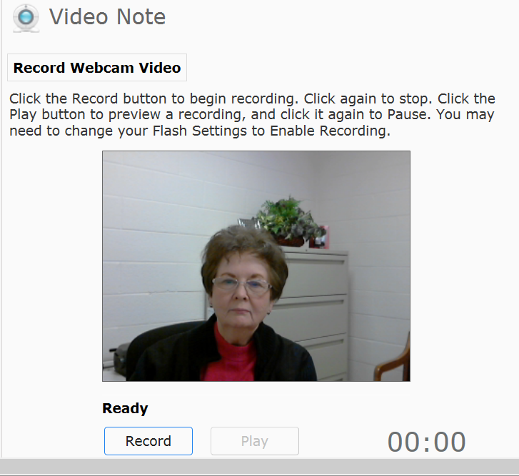
- Click on the “Record” button and record your message. Click the “Stop” button when you are finished. Click the “Play” button to review the video.
- Enter the Title and Description. Click on Next.
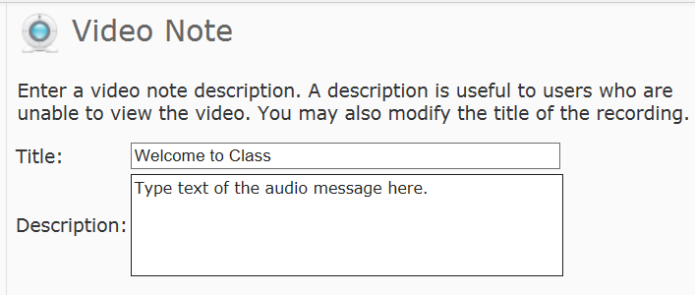
- Click on Insert.
- Click on Publish.

