Caption and Produce a Video Using Camtasia

How to Caption the Video
It most likely will take about five minutes to caption one minute of video. It is important to caption because students who are hearing impaired will have access to your video in compliance with the American with Disabilities act. It also provides another option for students to watch the videos in “quiet-zone” environments.
- Open Camtasia Studio and click on File, New Project.
- Click on File, Import Media to select the video you wish to caption. Supported file formats are camrec (Camtasia screen recorder format), avi, mp4, mpg, mpeg, wmv, mov, and swf.
- Drag and drop the video to the track. See the image below.
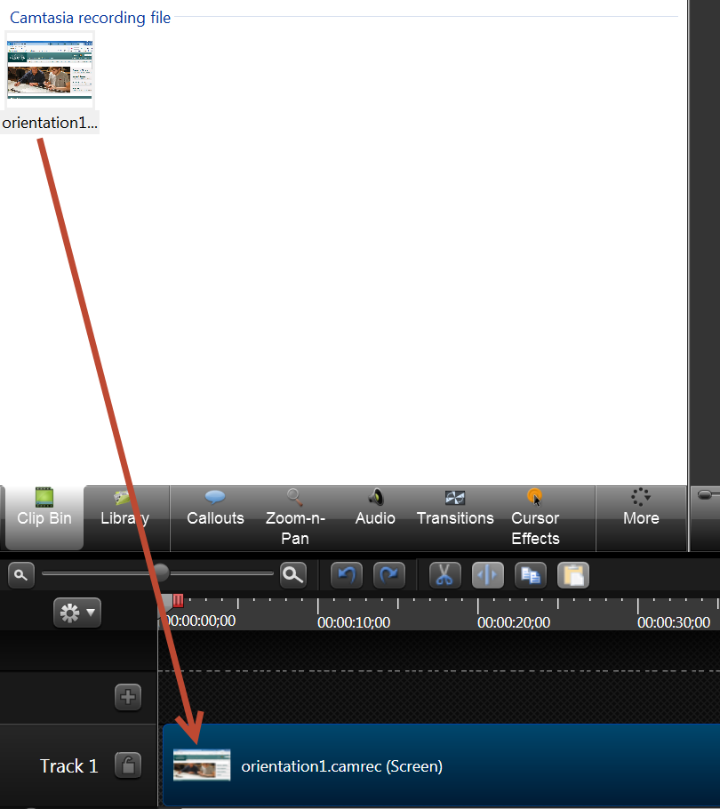
- Click on Captions.
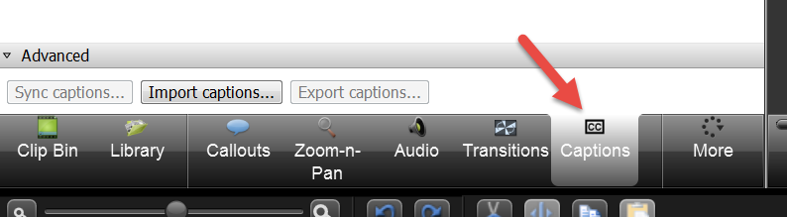
- Click on “Speech-to-text.” It is best to train your computer before beginning this option to obtain a better accuracy rate. To train speech-to-text, click on Control Panel, select Ease of Access then Speech Recognition. Click on “Train your computer to better understand you” and follow the training instructions. Only one voice at a time can be trained.
Select “Entire Timeline.”
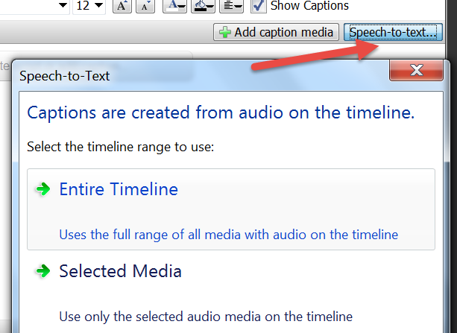

Edit the Captions
- Listen to and correct the captions.
- With the item selected, touch Enter to hear the caption read aloud. Edit the caption. Touch Tab to move to the next caption and touch Enter to hear it.
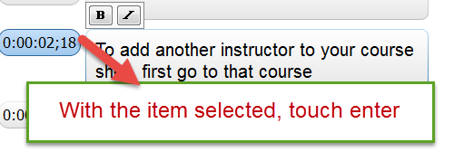
- If you have a caption three lines long, you may want to split it. To do so, click on the caption in the timeline and move the cursor to the center.
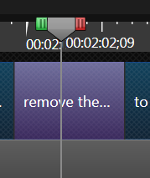
- Click on the Split button. This will create a duplicate.
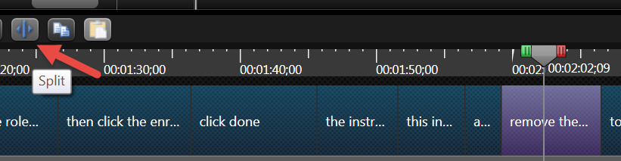
- Delete the ending words from the first copy and delete the beginning words from the second copy.
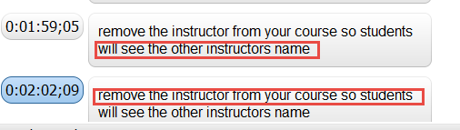

Produce the Video Using Camtasia
Camtasia can be used to produce the video. To produce a single mp4 video with burned-in captions,
- Click on Produce and Share. If this is a screen capture, produce the video using the same dimensions as the recorded video. If it is an imported video, choose the same dimension as the original video.
- Select “MP4 Only”—either up to 480 or 720p. You may want to explore the other production options.
- Close the screen describing unsupported options.
- Select the folder where the video is to be saved.
- Click on Finish.
NOTE: To record a video with closed captions, choose the Custom option and select MP4 Flash/HTML5. At the next screen, choose the Option tab and choose Closed Captions. This allows the user to turn caption on or off; however, rather than one mp4 file, multiple files are produced. To play the video, click on the HTML file.

Upload the Video to D2L
The file can be uploaded to D2L, to a website, or to YouTube. To upload it to D2L,
- Go to the course where it is to be uploaded.
- Click on Content. There are a number of options for displaying the video. One suggestion is to create a new file then embed the video.
  - Upload the file to Manage Files.
  - Click on Content and select Create a New File.
  - Enter a title for the file.
  - Click on the Insert Stuff icon.
  - Click on Course Offering Files. (If you did not upload the file, you can select My Computer and upload the file at this point.
  - Click the radio button next to the file name and click on Next.
  - Enter the information in the dialog box. Use the same width and height as the produced video.
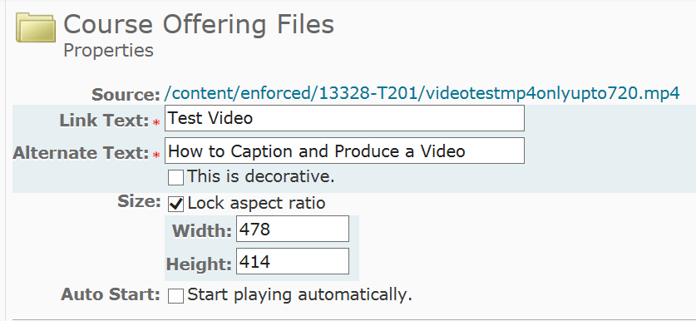
  - Click on Insert.
  - Click on Publish.

