Update Your D2L Courses After the Upgrade

Locate Resources
- Faculty resources are listed in the Faculty Support Services Widget inside D2L.
- Student resources are available through Help on the navigation bar in D2L.
- Faculty have banner_student access to an online D2L shell titled “Help and Training Videos.”
- Quick Guides are available on the D2L Guides page at http://ww2.nscc.edu/lyle_l.

Check the Navigation Bar
- Check to ensure that the new navigation bar is displayed in your course.
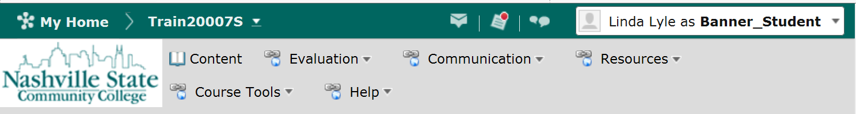
- If not, to change to the new view, click on the gear icon immediately below “My Home.”
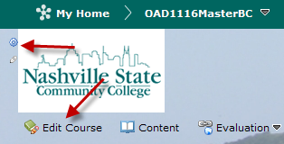
- Select NSCC V10 Course NavSlim from the list. Click on Apply. Please delete any old navigation bars that have a trash can icon next to the name.
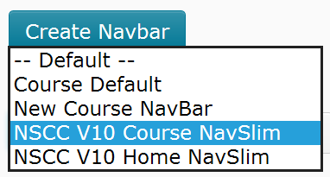
NOTE: If you need to add items to the navigation bar, go to http://ww2.nscc.edu/lyle_l and select D2L Guides. Scroll down to the Navigation section. Handouts are available to add system links (links that you do not have to create) and for custom links (links that you create linking to a file or URL.)

Upload a Syllabus

Create a New Module
Choose Content from the navigation bar.
Create a new Module if one does not exist. You must create a module before you can add a topic to the content. To create a module, click on "Add a module" in the left pane under Table of Contents unless a module already exists. If the module has already been created, click on the name of the module.
Type the module name. Enter to create the module.

Upload a Word or PDF Syllabus
NOTE: If you have active links in your syllabus that students need to follow, see the next section titled “Upload a Word or PDF Syllabus With Links.”

Click on Content then click the "New" button.
Select "Upload files."
Choose where the files will be uploaded from: My Computer or Course Offering Files.
Click on Upload.
Upload the file and click on Open.
Click on Done. To view the file, click on Content then click the link.
OR
Drag and Drop a File to Content
Click on Content and create or select a module from the left navigation.
If your browser supports drag and drop, you will see a specialized drop area.
Locate and select the files on your computer.
Drag one or more files to the specialized drop space.
- Browse to locate the file.
- Save.
- Click on Content and click the link to check to see if the file displays as expected.

Upload a Word or PDF Syllabus With Links
- Click on Edit Course.
- Select Manage Files.
- Click the Upload button and upload and save your syllabus to Manage Files area.
- Click on Content
- Create a Module, if needed.
- Click the New Button and choose Create a File.
- Type the title.
- Select a Template, if desired. Publish. Then click the arrow next to the title and choose Edit HTML.
- Click on Insert Quick Link.
- Click the arrow to the far right of Course File.
- Locate the Word or PDF File and click the icon to the far right of the file. This open a dialog box where you will key the words that will display as linked text. Choose Same Frame. Click on Insert.
- Click on Update.

Update Start, Due, and End Dates
- Check your dates by going to each tool or by going to Content if the dates are linked from the content area.
- From Content, click on Table of Contents.
- Click on any dates that are displayed, then change the dates.

Check Navigation and Links
- Go to Content.
- Click on each item from the content page.
- When other pages open, click on each link to make sure it opens in a way that does not get students lost in navigation.
- Check the links to ensure they are not broken. Broken links from the Content page are indicated by “Broken” as the title.
NOTE: It appears that all links from Content open in a new tab or window. It is also recommended that you open any links from pages you create in a new window.

Check the Default Setting for Tracking
Tracking allows students to see if they have completed a content item by automatically placing a check mark by completed items or by allowing students to manually check when the item has been completed.

Set Tracking Globally
- Go to Content.
- Click on Table of Contents.
- At the top of the screen, click the arrow next to Table of Contents and click on Set All Completion.
- Choose one of the three options.
- Click on Update.

Set Tracking for a Module
- Click on the module title at the left to display the module.
- At the top of the screen next to the module title, click the arrow. Click on Set all Completion.
- Choose one of the three options.
- Click on Update.

Set Tracking for a Topic
- Click the arrow next to the topic name.
- Choose Edit Properties in Place.
- Select one of the three options.

Select Items from Class Progress to Display for the Instructor
To access Class Progress and select progress indicators,
From the Course Tools menu, select User Progress.
Click on Settings and select the desired items--four indicators can be displayed.
Click on Save and Close.

To change progress indicators,
From the Course Tools menu, select User Progress.
Click on Settings.
Click the Action menu for the item to be changed.
Click on Replace.
Click on Save and Close.

Select Items from User Progress to Display for Students
- From the Course Tools group on the navigation bar, select User Progress.
- Click on any one student’s name.
- Uncheck the items you do not want the students to see. For example, if you do not use Surveys, uncheck that item.
- Below the list of items, set indicators for students who are on track, some concerns, and at risk.
- Click on Save and Close.
NOTE: AFTER the start date and BEFORE the close date for a course, the selected items will display; otherwise, you will see only Login History.

Update Get Help and User Progress
If you use the Get Help and User Progress in the Getting Started module for your course, the files are available for download as follows:
- Go to http://ww2.nscc.edu/lyle_l and click on D2L Q&A.
- Locate the fourth item titled “Where can I find the ‘Get Help’ and ‘Check User Progress’ pages to add to my course?”
- Download the files to your computer by right-clicking on each one and choosing “Save Target as.”
- Go to your course and click on Edit Course and Manage Files. Upload the four files into the same folder.
- Go to content and link to each of the html files.

Check Your Course for Specific D2L Instructions
If you have specific instructions for using D2L tools in your course, ensure that they have been updated to match the new interface.
NOTE: You may want to refer students to Help on the navigation bar. Those files will be updated when changes are made to D2L.

