**Intermediate Accounting I, ACCT-2321  
Exam 2 Study Guide: Chapters 5 – 7**

**Exam 2 is comprised of, multiple choice, short answer and problem questions. The study questions and sample problems below should help you prepare for the exam. Please note that the study format does not directly match the exam format.**

Solutions to multiple choice, identification, and problems can be found at the end of this study guide.

1. Explain when each of the following tables would be used.

a. Present Value of $1

b. Future Value of $1

2. Describe the difference between an ordinary annuity and an annuity due.

3. Describe each of the following cash elements and identify where you would find each item on a classified balance sheet.

a. Currency

b. Cash equivalents

c. Restricted cash

4. Explain the difference between simple and compound interest.

5. List and discuss four recommendations for internal control over cash.

6. Define the following:

a. Stated interest rate

b. effective interest rate

7. Demonstrate how accounts receivable should be presented in the balance sheet, assuming that the allowance for doubtful accounts is a material amount.

8. Describe the conditions under which a contract exists for purposes of applying the revenue recognition principle.

9. List the 5 steps for recognizing revenue.

10. State the Core Revenue Recognition principle.

11. Explain what a performance obligation is and describe the circumstances under which a performance obligation is satisfied.

**Problem 1**

Oswego Clay Pipe Company sold $46,000 of pipe to Southeast Water District #45 on April 12 of the current year with terms 1/15, n/60. Oswego uses the **gross method** of accounting for cash discounts. Record the following journal entries for Oswego Clay Pipe Company. You may ignore cost of goods sold.

1) The sale on April 12.

2) Assuming Southwest paid the amount due on April 23.

3) Assuming Southwest paid the amount due on June 10.

|  |  |  |  |
| --- | --- | --- | --- |
|  | Account | Debit | Credit |
| 1. |  |  |  |
|  |  |  |  |
|  |  |  |  |
| 2. |  |  |  |
|  |  |  |  |
|  |  |  |  |
|  |  |  |  |
| 3. |  |  |  |
|  |  |  |  |
|  |  |  |  |

**Problem 2**

Harvey's Wholesale Company sold supplies of $46,000 to Northeast Company on April 12 of the current year, with terms 1/15, n/60. Harvey’s uses the **net method** of accounting for cash discounts. Record the following journal entries for Harvey's Wholesale Company:

1) The sale on April 12.

2) Assuming Northeast paid the amount due on April 23.

3) Assuming Northeast paid the amount due on June 10.

|  |  |  |  |
| --- | --- | --- | --- |
|  | Account | Debit | Credit |
| 1. |  |  |  |
|  |  |  |  |
|  |  |  |  |
| 2. |  |  |  |
|  |  |  |  |
|  |  |  |  |
| 3. |  |  |  |
|  |  |  |  |
| . |  |  |  |

**Problem 3**

Burck Construction Company was the low bidder on a construction project to build a bridge for $1,800,000. The project was begun in 2016 and completed in 2017. Cost and other data are presented below.



**Requirement 1:**Assume the **percentage of completion** method is used.

**1)** What amount of gross profit (or loss) would Burck record on this project in each year? Place answers in the spaces provided below and show supporting computations.

|  |  |  |
| --- | --- | --- |
|  | 2016 | 2017 |
| Contract Price |  |  |
| Actual costs to date |  |  |
| Estimated costs to complete |  |  |
| Total estimated project costs |  |  |
| Percent Complete |  |  |
| Estimated Gross Profit |  |  |
| **Gross Profit Recognized** |  |  |

**2)** Prepare all journal entries for 2016 & 2017 to record 1) costs, 2) billings, 3) collections, 4) profit recognition, and 5) close accounts (2017 only). Journal paper is included on the next page.

|  |  |  |  |
| --- | --- | --- | --- |
| Date | Account | Debit | Credit |
| 2016 |  |  |  |
| 1. |  |  |  |
|  |  |  |  |
|  |  |  |  |
| 2. |  |  |  |
|  |  |  |  |
|  |  |  |  |
| 3. |  |  |  |
|  |  |  |  |
|  |  |  |  |
| 4. |  |  |  |
|  |  |  |  |
|  |  |  |  |
|  |  |  |  |
| 2017 |  |  |  |
| 1. |  |  |  |
|  |  |  |  |
|  |  |  |  |
| 2. |  |  |  |
|  |  |  |  |
|  |  |  |  |
| 3. |  |  |  |
|  |  |  |  |
|  |  |  |  |
| 4. |  |  |  |
|  |  |  |  |
|  |  |  |  |
|  |  |  |  |
| 5. |  |  |  |
|  |  |  |  |

**Problem 4**

Squeaky Shine provides car washing services in Jersey City, New Jersey. A three-month pass for automatic car wash sells for $60, which entitles the customer for an unlimited number of car washes during the contract period. Squeaky Shine estimates that pass holders wash their cars equally throughout the three-month period. On November 1, customers purchased and paid for $1,260 of the three-month passes, with purchases of the passes occurring evenly throughout December.

Prepare the journal entries that Squeaky Shine would record on November 1 and on December 31 of the current year with respect to this transaction.

|  |  |  |  |
| --- | --- | --- | --- |
| Date | Account | Debit | Credit |
|  |  |  |  |
|  |  |  |  |
|  |  |  |  |
|  |  |  |  |
|  |  |  |  |
|  |  |  |  |
|  |  |  |  |

**Problem 5**

AGC sells embossing machines and embossing folder sets. Folder sets are auto shipped to customers once a month over a 12 month period. Embossing machines sell separately for $120 and folder sets sell separately for $30 for each monthly set. AGC also sells a package which includes the embossing machine along with an auto shipment of folders for 12 months for a total cost of $400.

A customer places an order for AGS’s package deal on October 17 of the current year and receives the embossing machine along with the first month’s folder set on November 1. Record the necessary journal entries on November 1 and December 31, the fiscal year end.

|  |  |  |  |
| --- | --- | --- | --- |
| Date | Account | Debit | Credit |
|  |  |  |  |
|  |  |  |  |
|  |  |  |  |
|  |  |  |  |
|  |  |  |  |
|  |  |  |  |
|  |  |  |  |

**Problem 6**

Compute the future value of the following invested amounts at the specified periods and interest.

Invested Interest Number of

Item Amount Rate Periods

a. $20,000 8% 10

b. $30,000 4% 8

**Problem 7**

Compute the present value of the following single amounts to be received at the end of the specified period at the given interest rate.

Invested Interest Number of

Item Amount Rate Periods

a. $40,000 7% 20

b. $20,000 6% 25

**Problem 8**

Incognito Company is contemplating the purchase of a machine that provides it with net after-tax cash savings of $80,000 per year for five years. Interest is 8%. Assume the cash savings occur at the end of each year.

**Required:** Calculate the present value of the cash savings.

**Problem 9**

Tokyo Imports sold merchandise to Tall-Mart, receiving a six-month, noninterest-bearing note for $100,000. The implied discount rate on the note is 10% per annum. Tokyo uses a periodic inventory system.

**Required:**

1. Prepare the journal entry to record the sale.
2. Compute the effective rate of interest.

|  |  |  |  |
| --- | --- | --- | --- |
| Date | Account | Debit | Credit |
|  |  |  |  |
|  |  |  |  |
|  |  |  |  |
|  |  |  |  |

Effective Interest Rate computation:

**Problem 10**

San Mateo Company had the following account balances at December 31 of the current year before recording writing off accounts and recording bad debt expense for the year. San Mateo uses the allowance method of estimating bad debts.

Accounts receivable $1,400,000

Allowance for uncollectible accounts (credit balance) 22,000

Credit sales for current year 1,950,000

**Required:**

1) Prepare the entry to write off $10,000 of accounts as uncollectible

2) Prepare the adjusting entry for recording uncollectible accounts using

a) the Income Statement Approach based on 3% of credit sales

b) the Balance Sheet Approach based on 6% of year-end accounts receivable

|  |  |  |  |
| --- | --- | --- | --- |
| Date | Account | Debit | Credit |
| 1) |  |  |  |
|  |  |  |  |
|  |  |  |  |
| 2)a |  |  |  |
|  |  |  |  |
|  |  |  |  |
| 2)b |  |  |  |
|  |  |  |  |

**Intermediate Accounting I, ACCT-2321  
Exam 2 Study Guide: Chapters 5 – 7   
*Answer Key***

**Problem 1**

|  |  |  |  |
| --- | --- | --- | --- |
|  | Account | Debit | Credit |
| **1.** | Accounts Receivable | 46,000 |  |
|  | Sales |  | 46,000 |
|  |  |  |  |
| **2.** | Cash | 45,540 |  |
|  | Sales Discounts *($46,000 X .01)* | 460 |  |
|  | Accounts Receivable |  | 46,000 |
|  |  |  |  |
| **3.** | Cash | 46,000 |  |
|  | Accounts Receivable |  | 46,000 |

**Problem 2**

|  |  |  |  |
| --- | --- | --- | --- |
|  | Account | Debit | Credit |
| **1.** | Accounts Receivable | 45,540 |  |
|  | Sales ($46,000 X .99) |  | 45,540 |
|  |  |  |  |
| **2.** | Cash | 45,540 |  |
|  | Accounts Receivable |  | 45,540 |
|  |  |  |  |
| **3.** | Cash | 46,000 |  |
|  | Accounts Receivable |  | 45,540 |
|  | Interest Revenue |  | 460 |

**Problem 3-1**

|  |  |  |
| --- | --- | --- |
|  | 2016 | 2017 |
| Contract Price | 1,800,000 | 1,800,000 |
| Actual costs to date | 450,000 | 1,550,000 |
| Estimated costs to complete | 1,050,000 | -0- |
| Total estimated project costs | 1,500,000 | 1,550,000 |
| Percent Complete | 30% | 100% |
| Estimated Gross Profit | 300,000 | 250,000 |
| **Gross Profit Recognized** | **$90,000** | **$160,000** |

**Supporting Calculations**



**Problem 3-2**

**Journal Entries**

2016

2017

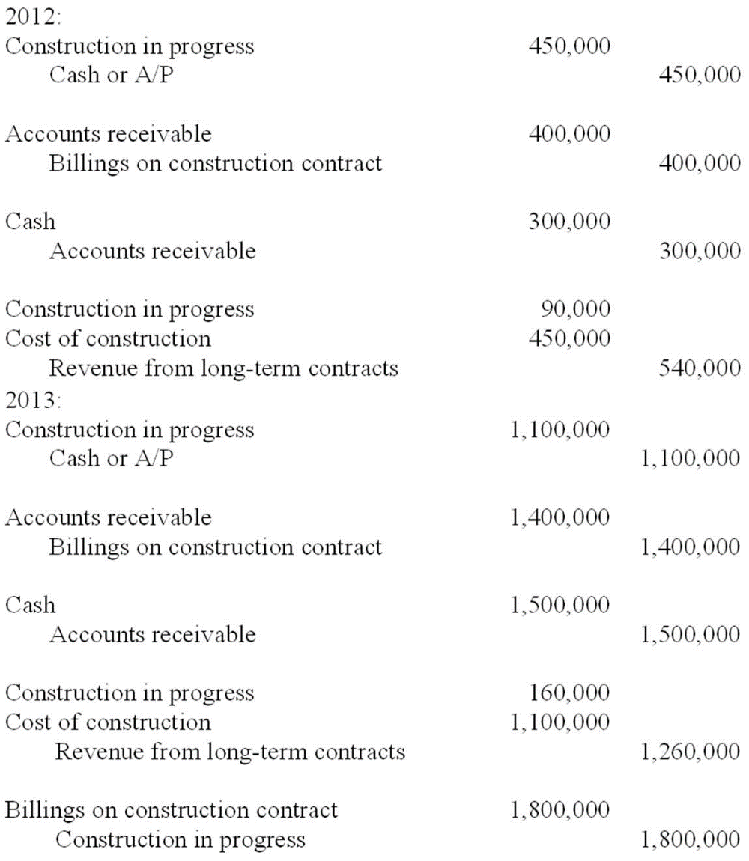

**Problem 4**

|  |  |  |  |
| --- | --- | --- | --- |
| Date | Account | Debit | Credit |
| Nov 1 | Cash | 1,260 |  |
|  | Deferred Revenue |  | 1,260 |
|  |  |  |  |
| Dec 31 | Deferred Revenue | 840 |  |
|  | Sales Revenue* |  | 840 |

*$1,260 / 3 months = $420 per month X 2 months of use = $840

**Problem 5**

AGC sells embossing machines and embossing folder sets. Folder sets are auto shipped to customers once a month over a 12 month period. Embossing machines sell separately for $120 and folder sets sell separately for $30 for each monthly set. AGC also sells a package which includes the embossing machine along with an auto shipment of folders for 12 months for a total cost of $400.

A customer placed an order for AGS’s package deal on October 17 of the current year and receives the embossing machine along with the first month’s folder set on November 1. Record the necessary journal entries on November 1 and December 31, the fiscal year end.

|  |  |  |  |
| --- | --- | --- | --- |
| Date | Account | Debit | Credit |
| Nov 1 | Accounts Receivable | 400 |  |
|  | Sales Revenue |  | 125 |
|  | Deferred Revenue |  | 275 |
|  |  |  |  |
| Dec 31 | Deferred Revenue | 25 |  |
|  | Sales Revenue |  | 25 |

**Supporting Calculations:**

This transaction includes two performance obligations: One for the embossing machine and a second obligation for the embossing folders.

1. Allocate the transaction price to each performance obligation in proportion to the stand-alone selling prices.



1. Determine the amount of revenue to be recognized on November 1.
   1. $100 of revenue should be recognized for the embossing machine since this product has been delivered to the customer.
   2. $25 of revenue should be recognized for the embossing folders since the first set of monthly folders was delivered with the embossing machine.
   3. The remaining $275 is deferred revenue for the remaining 11 folder shipments at $25 each.
2. $25 of revenue will be recognized on December 31 since the December folder shipment has been sent to the customer.

**Problem 6**

a. FV = $20,000 (2.15892) = **$43,178**

Future value of $1: *n* = 10, *i* = 8% (from Table 1)

b. FV = $30,000 (1.36857) = **$41,057**

Future value of $1: *n* = 8, *i* = 4% (from Table 1)

**Problem 7**

a. PV = $40,000 (.25842) = **$10,337**

Present value of $1: *n* = 20, *i* = 7% (from Table 2)

b. PV = $20,000 (.23300) = **$4,660**

Present value of $1: *n* = 25, *i* = 6% (from Table 2)

**Problem 8**

PVA = $80,000 x 3.99271 = $319,417

Present value of an ordinary annuity of $1: *n* = 5, *i* = 8% (from Table 4)

**Problem 9**

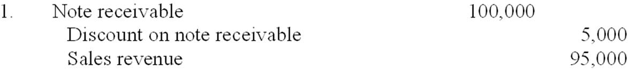   
  
2. Effective interest rate = ($5,000/$95,000) x 2 = 10.53%

**Problem 10**

|  |  |  |  |
| --- | --- | --- | --- |
| Date | Account | Debit | Credit |
| 1) | Allowance for Uncollectible Accounts | 10,000 |  |
|  | Accounts Receivable |  | 10,000 |
|  |  |  |  |
| 2)a | Bad Debts Expense | 58,500 |  |
|  | Allowance for Uncollectible Accounts |  | 58,500 |
|  |  |  |  |
| 2)b | Bad Debts Expense | 71,400 |  |
|  | Allowance for Uncollectible Accounts |  | 71,400 |
|  |  |  |  |

**Supporting Calculations**

1) Percentage of credit sales approach: $1,950,000 x 3% = $58,500   
2) Percentage of receivables approach:

Ending balance in Accounts receivable: $1,400,000 - $10,000 = $1,390,000

Ending balance in Allowance for Uncollectible Accounts: $22,000 – $10,000 = $12,000

Calculation of Bad Debts Expense:

$1,390,000 x 6% = $83,400 - $12,000 = $71,400