**Intermediate Accounting I, ACCT-2321  
Exam 2 Study Guide: Chapters 5 – 7**

**Exam 2 is comprised of, multiple choice, short answer and problem questions. The study questions and sample problems below should help you prepare for the exam. Please note that the study format does not directly match the exam format.**

Solutions to multiple choice, identification, and problems can be found at the end of this study guide.

1. Explain when each of the following tables would be used.

a. Present Value of $1

b. Future Value of $1

2. Describe the difference between an ordinary annuity and an annuity due.

3. Describe each of the following cash elements and identify where you would find each item on a classified balance sheet.

a. Currency

b. Cash equivalents

c. Restricted cash

4. Explain the difference between simple and compound interest.

5. List and discuss four recommendations for internal control over cash.

6. Define the following:

a. Stated interest rate

b. effective interest rate

7. Demonstrate how accounts receivable should be presented in the balance sheet, assuming that the allowance for doubtful accounts is a material amount.

**Problem 1**

Oswego Clay Pipe Company sold $46,000 of pipe to Southeast Water District #45 on April 12 of the current year with terms 1/15, n/60. Oswego uses the **gross method** of accounting for cash discounts. Record the following journal entries for Oswego Clay Pipe Company. You may ignore cost of goods sold.

1) The sale on April 12.

2) Assuming Southwest paid the amount due on April 23.

3) Assuming Southwest paid the amount due on June 10.

|  |  |  |  |
| --- | --- | --- | --- |
|  | Account | Debit | Credit |
| 1. |  |  |  |
|  |  |  |  |
|  |  |  |  |
| 2. |  |  |  |
|  |  |  |  |
|  |  |  |  |
|  |  |  |  |
| 3. |  |  |  |
|  |  |  |  |
|  |  |  |  |

**Problem 2**

Harvey's Wholesale Company sold supplies of $46,000 to Northeast Company on April 12 of the current year, with terms 1/15, n/60. Harvey’s uses the **net method** of accounting for cash discounts.Record the following journal entries for Harvey's Wholesale Company:

1) The sale on April 12.

2) Assuming Northeast paid the amount due on April 23.

3) Assuming Northeast paid the amount due on June 10.

|  |  |  |  |
| --- | --- | --- | --- |
|  | Account | Debit | Credit |
| 1. |  |  |  |
|  |  |  |  |
|  |  |  |  |
| 2. |  |  |  |
|  |  |  |  |
|  |  |  |  |
| 3. |  |  |  |
|  |  |  |  |
| . |  |  |  |

**Problem 3**

Burck Construction Company was the low bidder on a construction project to build a bridge for $1,800,000. The project was begun in 2012 and completed in 2013. Cost and other data are presented below.

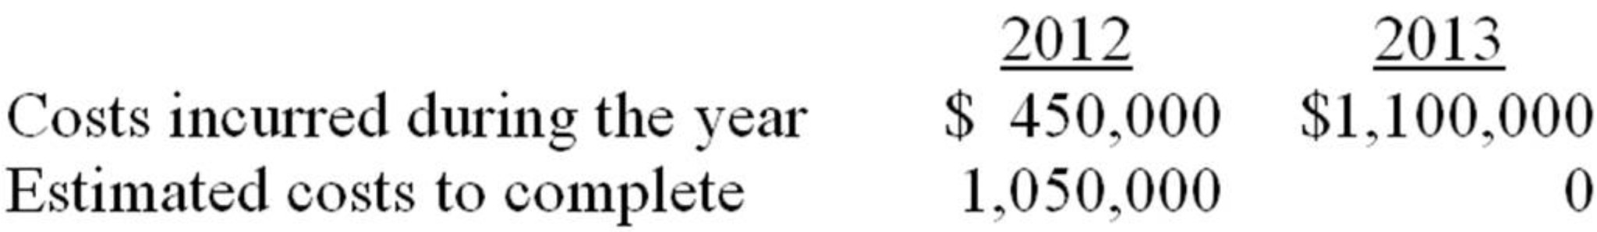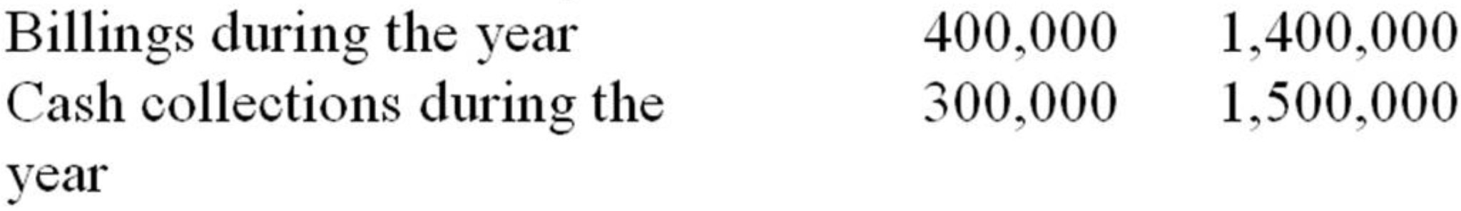

**Requirement 1:**Assume the **percentage of completion** method is used.

**1)** What amount of gross profit (or loss) would Burck record on this project in each year? Place answers in the spaces provided below and show supporting computations.

|  |  |  |
| --- | --- | --- |
|  | 2012 | 2013 |
| Contract Price |  |  |
| Actual costs to date |  |  |
| Estimated costs to complete |  |  |
| Total estimated project costs |  |  |
| Percent Complete |  |  |
| Estimated Gross Profit |  |  |
| **Gross Profit Recognized** |  |  |

**2)** Prepare all journal entries for 2012 & 2013 to record 1) costs, 2) billings, 3) collections, 4) profit recognition, and 5) close accounts (2013 only).

|  |  |  |  |
| --- | --- | --- | --- |
| Date | Account | Debit | Credit |
| 2012 |  |  |  |
| 1. |  |  |  |
|  |  |  |  |
|  |  |  |  |
| 2. |  |  |  |
|  |  |  |  |
|  |  |  |  |
| 3. |  |  |  |
|  |  |  |  |
|  |  |  |  |
| 4. |  |  |  |
|  |  |  |  |
|  |  |  |  |
|  |  |  |  |
| 2013 |  |  |  |
| 1. |  |  |  |
|  |  |  |  |
|  |  |  |  |
| 2. |  |  |  |
|  |  |  |  |
|  |  |  |  |
| 3. |  |  |  |
|  |  |  |  |
|  |  |  |  |
| 4. |  |  |  |
|  |  |  |  |
|  |  |  |  |
|  |  |  |  |
| 5. |  |  |  |
|  |  |  |  |

**Problem 3  
Requirement 2:**Assume the **completed contract** method is used.

**1)** What amount of gross profit (or loss) would Burck record on this project in each year? Place answers in the spaces provided below and show supporting computations.

|  |  |  |
| --- | --- | --- |
|  | 2012 | 2013 |
| **Gross Profit Recognized** |  |  |

**2)** Prepare all journal entries for 2012 & 2013 to record 1) costs, 2) billings, 3) collections, 4) profit recognition, and 5) close accounts (2013 only).

|  |  |  |  |
| --- | --- | --- | --- |
| Date | Account | Debit | Credit |
| 2012 |  |  |  |
| 1. |  |  |  |
|  |  |  |  |
|  |  |  |  |
| 2. |  |  |  |
|  |  |  |  |
|  |  |  |  |
| 3. |  |  |  |
|  |  |  |  |
|  |  |  |  |
| 2013 |  |  |  |
| 1. |  |  |  |
|  |  |  |  |
|  |  |  |  |
| 2. |  |  |  |
|  |  |  |  |
|  |  |  |  |
| 3. |  |  |  |
|  |  |  |  |
|  |  |  |  |
| 4. |  |  |  |
|  |  |  |  |
|  |  |  |  |
|  |  |  |  |
| 5. |  |  |  |
|  |  |  |  |

**Problem 4**

Benny Contractors received a contract to construct a medical facility for $2,500,000. Construction was begun in 2012 and completed in 2013. Cost and other data are presented below:

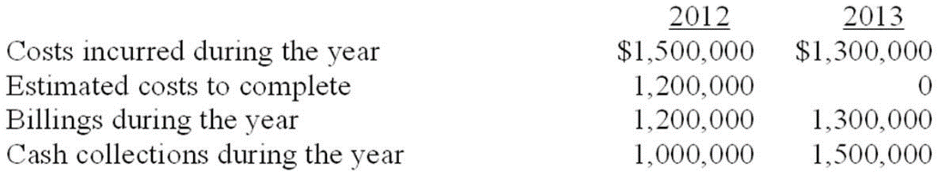

|  |  |
| --- | --- |
|  |  |

**Required:   
1)** What amount of gross profit (or loss) would Benny record on this project in each year under the **completed contract** method? Place answers in the spaces provided below and show supporting computations.

|  |  |  |
| --- | --- | --- |
|  | 2012 | 2013 |
| **Gross Profit Recognized** |  |  |

**Problem 5**

Compute the future value of the following invested amounts at the specified periods and interest.

Invested Interest Number of

Item Amount Rate Periods

a. $20,000 8% 10

b. $30,000 4% 8

**Problem 6**

Compute the present value of the following single amounts to be received at the end of the specified period at the given interest rate.

Invested Interest Number of

Item Amount Rate Periods

a. $40,000 7% 20

b. $20,000 6% 25

**Problem 7**

Incognito Company is contemplating the purchase of a machine that provides it with net after-tax cash savings of $80,000 per year for five years. Interest is 8%. Assume the cash savings occur at the end of each year.

**Required:** Calculate the present value of the cash savings.

**Problem 8**

Iowa Development (ID) made the following land sales and had the following cash collections. Assume ID cannot estimate uncollectible accounts accurately and recognizes revenue using the **installment method**.

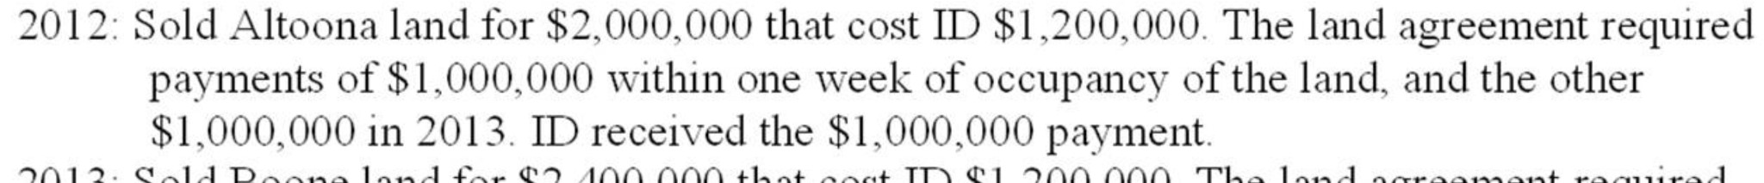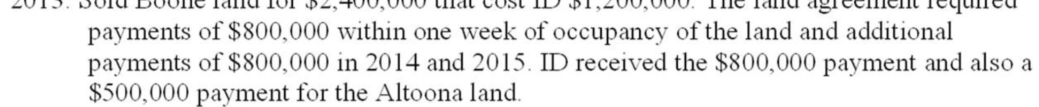

**Required:** Prepare journal entries to record the sale, cash collections, and recognition of gross profit (if appropriate) in 2012 and 2013

|  |  |  |  |
| --- | --- | --- | --- |
| Date | Account | Debit | Credit |
| 2012 |  |  |  |
| 1. |  |  |  |
|  |  |  |  |
|  |  |  |  |
|  |  |  |  |
| 2. |  |  |  |
|  |  |  |  |
|  |  |  |  |
| 3. |  |  |  |
|  |  |  |  |
|  |  |  |  |
| 2013 |  |  |  |
| 1. |  |  |  |
|  |  |  |  |
|  |  |  |  |
|  |  |  |  |
| 2. |  |  |  |
|  |  |  |  |
|  |  |  |  |
| 3. |  |  |  |
|  |  |  |  |
|  |  |  |  |

**Problem 9**

Tokyo Imports sold merchandise to Tall-Mart, receiving a six-month, noninterest-bearing note for $100,000. The implied discount rate on the note is 10% per annum. Tokyo uses a periodic inventory system.

**Required:**

1. Prepare the journal entry to record the sale.
2. Compute the effective rate of interest.

|  |  |  |  |
| --- | --- | --- | --- |
| Date | Account | Debit | Credit |
|  |  |  |  |
|  |  |  |  |
|  |  |  |  |
|  |  |  |  |

Effective Interest Rate computation:

**Problem 10**

San Mateo Company had the following account balances at December 31, 2013, before recording writing off accounts and recording bad debt expense for the year. San Mateo uses the allowance method of estimating bad debts.

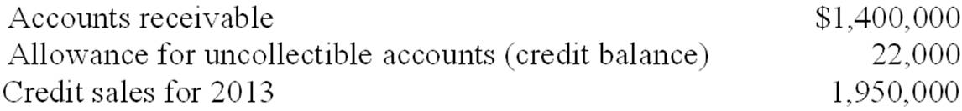

**Required:**

1) Prepare the entry to write off $10,000 of accounts as uncollectible

2) Prepare the adjusting entry for recording uncollectible accounts using

a) the Income Statement Approach based on 3% of credit sales

b) the Balance Sheet Approach based on 6% of year-end accounts receivable

|  |  |  |  |
| --- | --- | --- | --- |
| Date | Account | Debit | Credit |
| 1) |  |  |  |
|  |  |  |  |
|  |  |  |  |
| 2)a |  |  |  |
|  |  |  |  |
|  |  |  |  |
| 2)b |  |  |  |
|  |  |  |  |

**Intermediate Accounting I, ACCT-2154  
Exam 2 Study Guide: Chapters 5 – 7   
*Answer Key***

**Problem 1**

|  |  |  |  |
| --- | --- | --- | --- |
|  | Account | Debit | Credit |
| **1.** | Accounts Receivable | 46,000 |  |
|  | Sales |  | 46,000 |
|  |  |  |  |
| **2.** | Cash | 45,540 |  |
|  | Sales Discounts *($46,000 X .01)* | 460 |  |
|  | Accounts Receivable |  | 46,000 |
|  |  |  |  |
| **3.** | Cash | 46,000 |  |
|  | Accounts Receivable |  | 46,000 |

**Problem 2**

|  |  |  |  |
| --- | --- | --- | --- |
|  | Account | Debit | Credit |
| **1.** | Accounts Receivable | 45,540 |  |
|  | Sales ($46,000 X .99) |  | 45,540 |
|  |  |  |  |
| **2.** | Cash | 45,540 |  |
|  | Accounts Receivable |  | 45,540 |
|  |  |  |  |
| **3.** | Cash | 46,000 |  |
|  | Accounts Receivable |  | 45,540 |
|  | Interest Revenue |  | 460 |

**Problem 3-1**

|  |  |  |
| --- | --- | --- |
|  | 2012 | 2013 |
| Contract Price | 1,800,000 | 1,800,000 |
| Actual costs to date | 450,000 | 1,550,000 |
| Estimated costs to complete | 1,050,000 | -0- |
| Total estimated project costs | 1,500,000 | 1,550,000 |
| Percent Complete | 30% | 100% |
| Estimated Gross Profit | 300,000 | 250,000 |
| **Gross Profit Recognized** | **$90,000** | **$160,000** |

**Supporting Calculations**

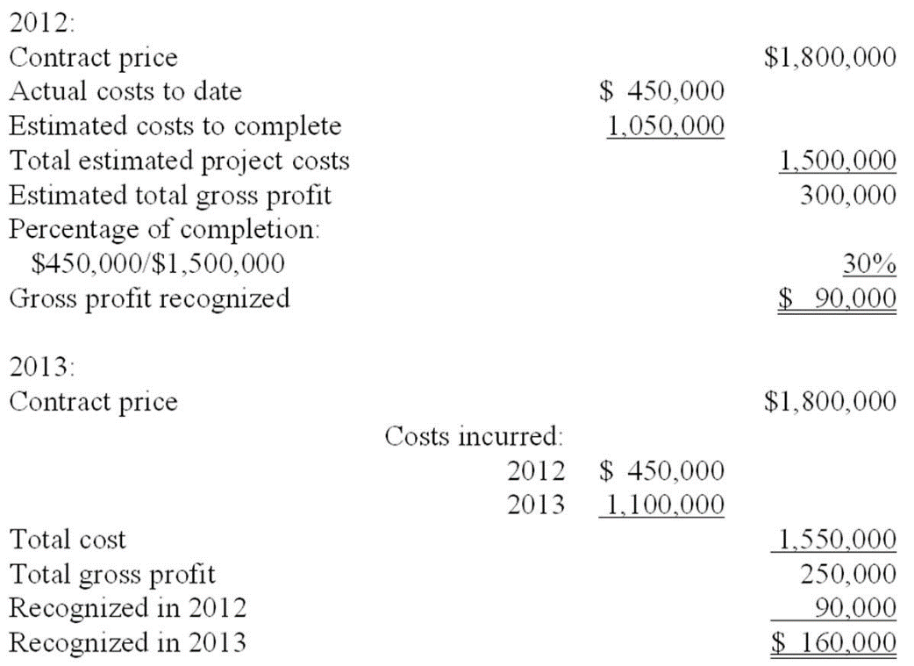

**Journal Entries**

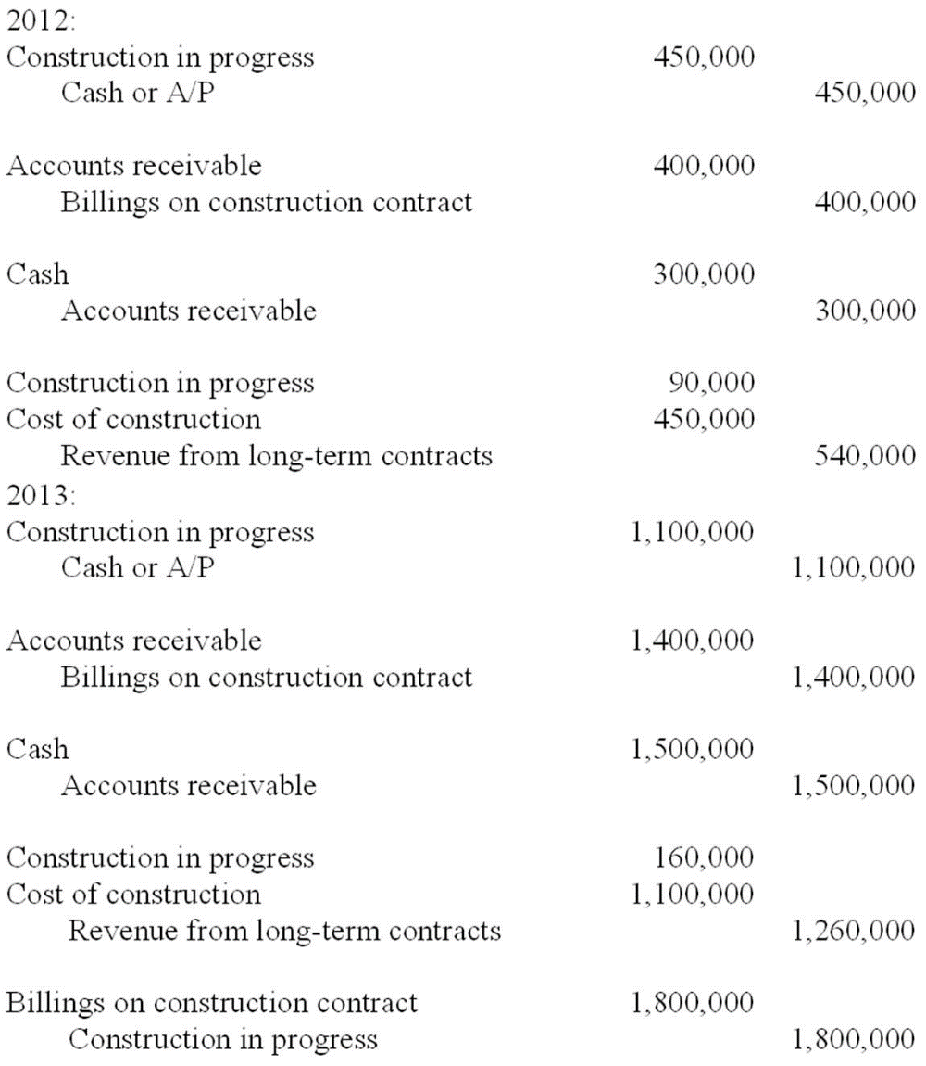

**Problem 3-2**

|  |  |  |
| --- | --- | --- |
|  | 2012 | 2013 |
| **Gross Profit Recognized** | **$0** | **$250,000** |

**Supporting Calculations**

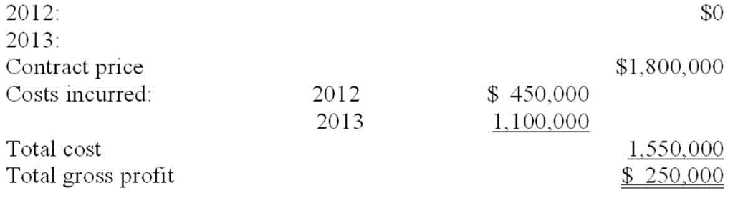

**Journal Entries**

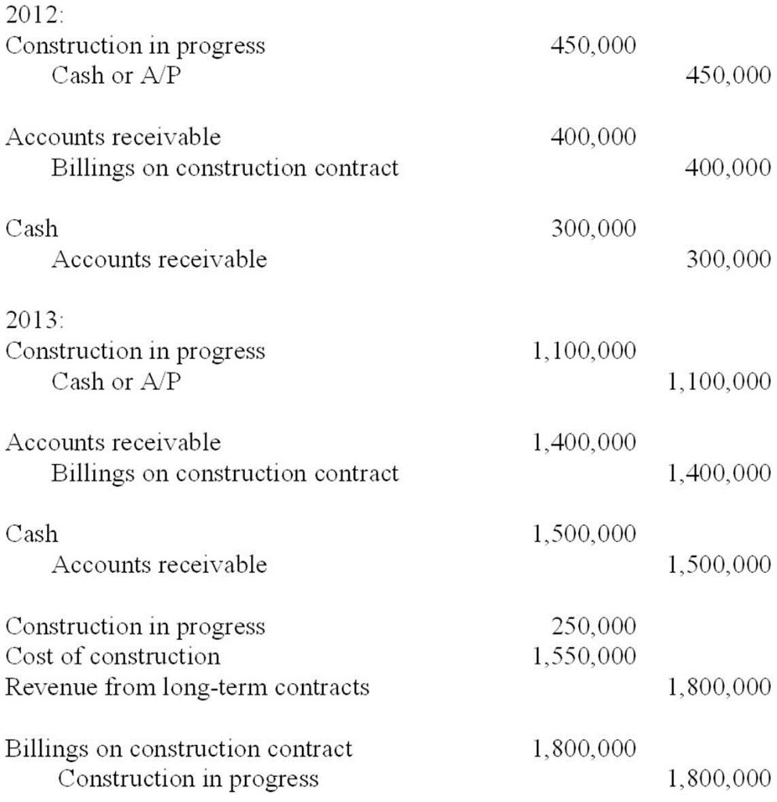

**Problem 4**

|  |  |  |
| --- | --- | --- |
|  | 2012 | 2013 |
| **Loss Recognized** | **<200,000>** | **<100,000>** |

**Supporting Calculations**

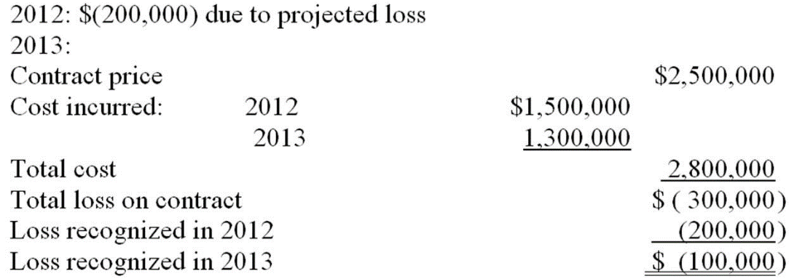

**Problem 5**

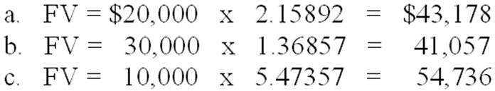

**Problem 6**

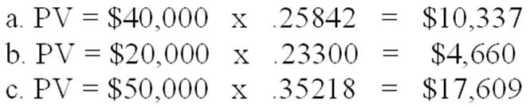

**Problem 7**

PVA = $80,000 x 3.99271 = $319,417

**Problem 8**

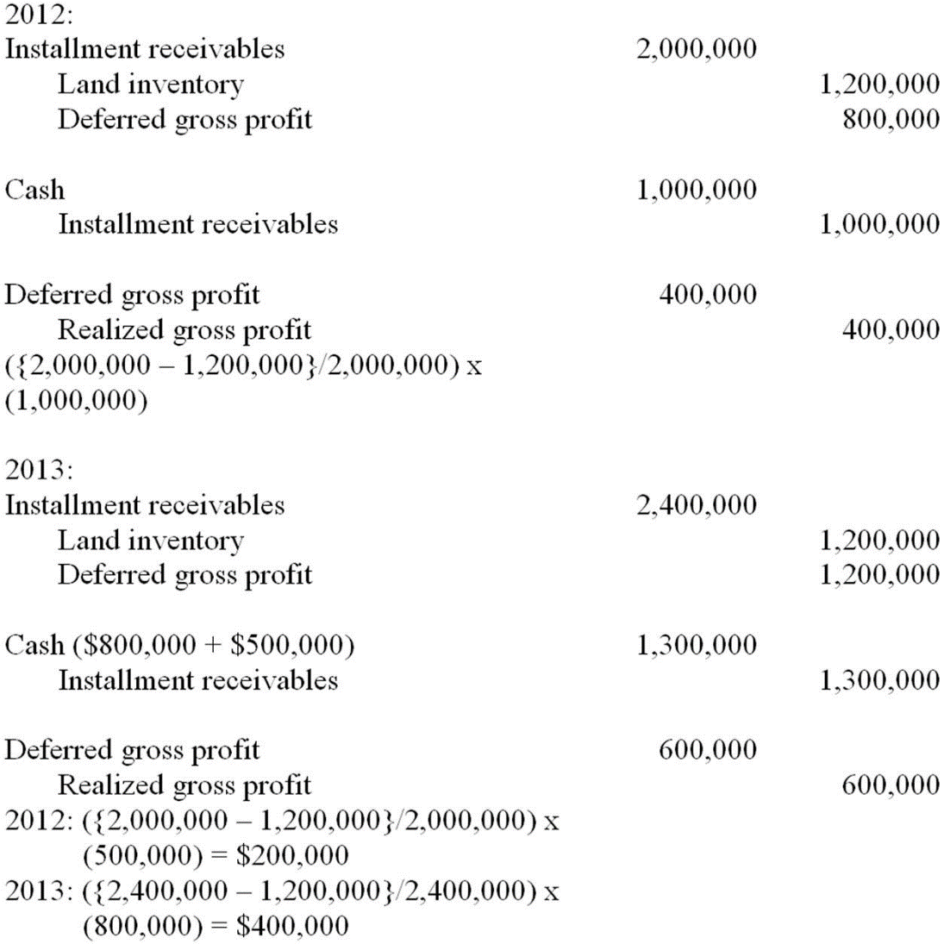

**Problem 9**

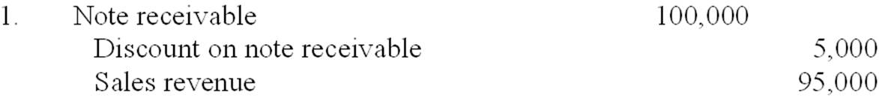   
  
2. Effective interest rate = ($5,000/$95,000) x 2 = 10.53%

**Problem 10**

|  |  |  |  |
| --- | --- | --- | --- |
| Date | Account | Debit | Credit |
| 1) | Allowance for Uncollectible Accounts | 10,000 |  |
|  | Accounts Receivable |  | 10,000 |
|  |  |  |  |
| 2)a | Bad Debts Expense | 58,500 |  |
|  | Allowance for Uncollectible Accounts |  | 58,500 |
|  |  |  |  |
| 2)b | Bad Debts Expense | 71,400 |  |
|  | Allowance for Uncollectible Accounts |  | 71,400 |
|  |  |  |  |

**Supporting Calculations**

1) Percentage of credit sales approach: $1,950,000 x 3% = $58,500   
2) Percentage of receivables approach:

Ending balance in Accounts receivable: $1,400,000 - $10,000 = $1,390,000

Ending balance in Allowance for Uncollectible Accounts: $22,000 – $10,000 = $12,000

Calculation of Bad Debts Expense:

$1,390,000 x 6% = $83,400 - $12,000 = $71,400