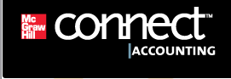
How to Purchase Connect Online

Step 1: Enter the URL given to you by your instructor on your course syllabus to access the Connect site for your Principles of Accounting I course.

Step 2: Make sure the page you landed on is the correct section and instructor for your Principles of Accounting course. Note: The course shown in the screenshot below is just an example. Be sure your Connect web page contains the correct course name and instructor.

Step 3: Click the Register Now button (circled below).

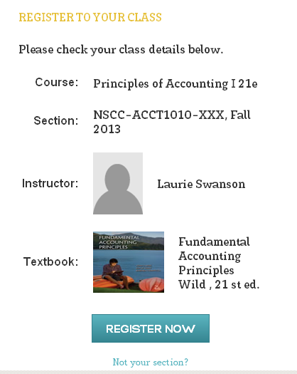
Your Instructor

Step 4: Enter your email address so the system can check to see if you already have a McGraw-Hill Higher Education account; most likely you will not. Click the Submit button.

Step 5: On the next page, click the Buy Online button (circled below).

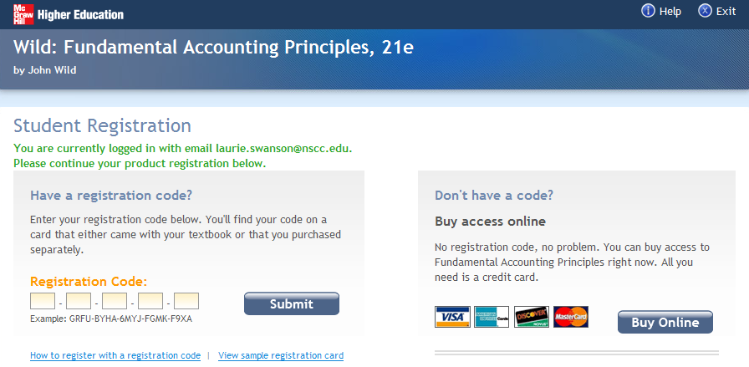

Step 6: You will see two purchase options. The first purchase option is for ConnectPlus. With this purchase you receive Connect as well as the interactive web-based ebook.

The second purchase option is for Connect only. This is the basic version of Connect and can be used to complete homework for this course but does not include access to the ebook.

Click the option matching your preference.

Step 7: On the next page, review your product selection and pricing. If the selection is correct, click the Submit button.

Step 8: If you do not already have a McGraw-Hill Higher Education account, you will need to create one now. To create an account, enter your email address, a memorable password, and your name. Be sure to remember or write down your password.

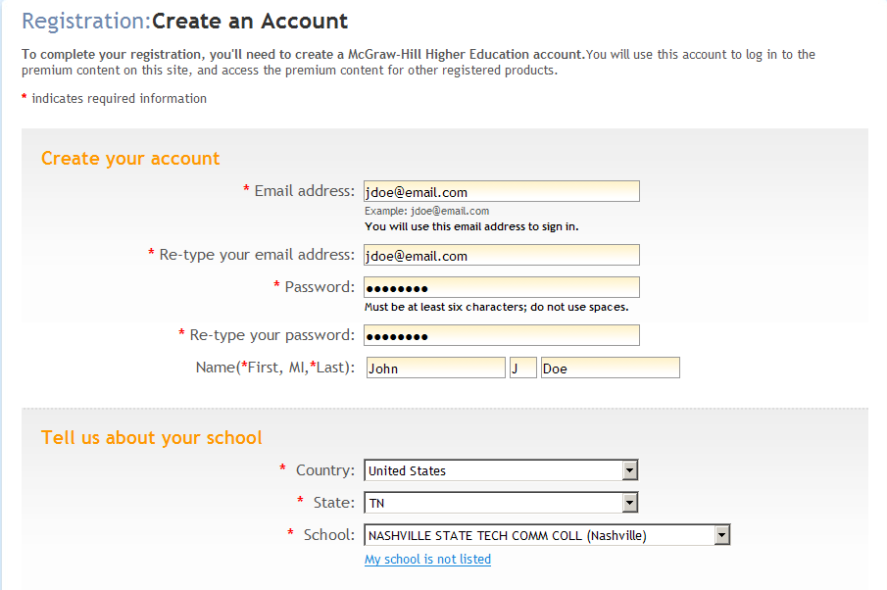

Step 9: Complete the requested information on this screen. Nashville State will be listed in the School drop-down list once you have entered a state. After completing all the information on this page, click Continue.

Step 10: The next screen is where you enter your billing and payment information. When complete, click the Submit button.

Step 11: If your order information is correct, click Place My Order. You will then go to a screen confirming that you have successfully completed your purchase and registered for Connect. You may also print a receipt of your purchase on this page.

Step 12: Click the link to go to your course’s Connect home page (shown below).

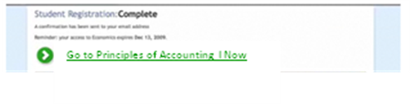
You are now ready to begin using Connect. When you log off, you can return to your Connect site using the URL address provided on the first page. Enter your email and password in the boxes on the left side of the screen and click Sign In. Follow the instructions for using Connect provided by your instructor.

Connect Support Information:
  - 800-331-5094, option 2
  - www.mhhe.com/support
  - Student video tutorials for help embedded within Connect

