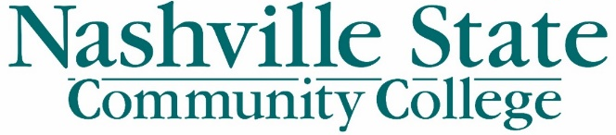
Fall Convocation: August 14, 2019
Moving Forward
Alignment, Accountability, and Action
H Building Auditorium
Presiding: Terry Naylor, Chair, NSCC Staff Assembly
7:30 – 8:15 Registration and Morning Refreshments – 1st Floor – H-Building
- Registration/Schedule/Lanyard pickup – H Building, 1st Floor Lobby
- Morning Refreshments – Art Gallery – H-141-142
- Regular Faculty Contract Signing – Side Hallway outside Art Gallery
- Photo ID Office – S-107 open 7:15 am – 8:15am
- NSCC Memories and “Why NSCC” recollections board – 1st Floor Lobby
8:00 Auditorium opens
8:30 – 10: 00 AM Welcome!
Service Awards, Promotions, and Updates
10:00 – 10:15 AM Break
10:15 – 10:45 Celebrating Our Successes
10:45 – 11:30 Jaqueline Faulkner, Vice President of Student Affairs
Southwest Community College
11:30 Lunch on own
Photo ID Office open 11:30 – 12:45, S107- Student Services Center
 | Green Star Group: H Auditorium | Gold Star Group: Clement Auditorium
1:00 – 1:45 | The NSCC Experience; Mia Sneed, Lisa Davies, Jared Irvine | Achieving the Dream: What is it, what does it mean for our students and what is next? Mary Womack, Lindsay Alderman, Kim Silverman
1:45 – 2:00 | Break | Break
2:00 – 2:45 | Achieving the Dream: What is it, what does it mean for our students and what is next? Mary Womack, Lindsay Alderman, Kim Silverman | The NSCC Experience; Mia Sneed, Lisa Davies, Jared Irvine

2:45 All move to H building auditorium
3:00 Moving Forward: Alignment, Accountability, and Action Dr. Shanna Jackson
3:15 A Celebration of Ted Washington and Scholarship Award
3:30 Reception Art Gallery

