

***TILT Transparent Instruction Survey – Fall 2021***

**Overall Results**

**BACKGROUND**

The Transparency in Learning and Teaching in Higher Education project (TILT Higher Ed) developed a comprehensive survey instrument that addresses academic confidence, sense of belonging, and mastery of the skills that employers value most when hiring. A set of nine questions that create a ‘Perceived amount of transparency in a course’ scale. A short online survey was constructed to determine if our students perceive our TILT courses are transparent.

**METHOD**

The scale consists of nine individual statements. The statements are as follows:

* In this course, I knew the purpose of each assignment.
* Each assignment included a section that explained how the assignment was related to the objectives of the course.
* My instructor identified a specific learning goal for each assignment.
* In this course, I knew the steps required to complete my assignments.
* Each assignment included a detailed set of instructions for completing it.
* My instructor provided detailed directions for each learning activity that was assigned.
* In this course, I knew how my work would be evaluated.
* My instructor provided students with annotated examples of past students’ work.
* My instructor provided tools I could use to assess the quality of my and others work.

Response options for the statements are: (1) Never, (2) Sometimes, (3) Often, and (4) Always. The individual statements are summed then averaged to provide a scale score between 1 and 4.

**ADMINISTRATION**

Target population(s): Students enrolled in Fall 2021 course sections using the TILT method.

Method: Online survey via SurveyMonkey with invitation from faculty in TILT sections who volunteered to promote survey.

Survey administration period: 11/16/2021 – 12/12/2021

**RESPONSES**

A total of 338 students responded to the survey across 14 subject areas, 31 courses, and 70 sections. Below are the number of responses by subject area.



**OVERALL RESULTS**

The average transparency scale score for the entire population is **3.64**, between ‘Often’ and ‘Always.’ Distributions for the individual statements, as well as basic demographics, can be found at <https://www.surveymonkey.com/stories/SM-PRMDMRNQ/>.

**SUBJECT AND COURSE SCORES**

Below are the average transparency scale scores by subject (COMM, ENGL, etc.) and course (COMM2025, ENGL1010, etc.) for those subjects and courses that have a minimum of 10 respondents.

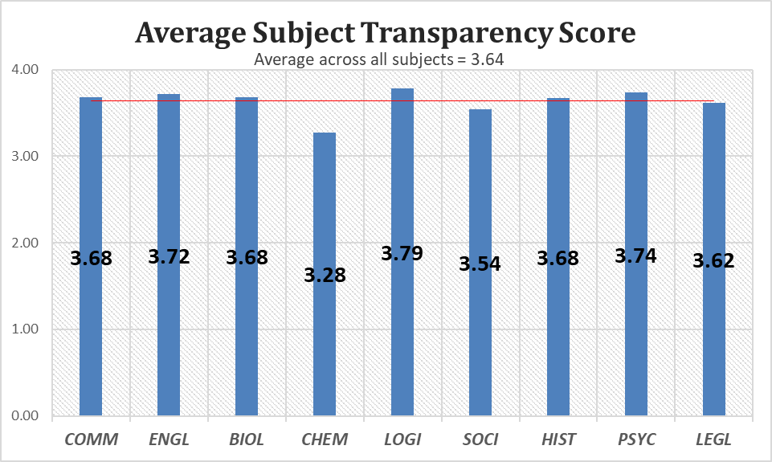

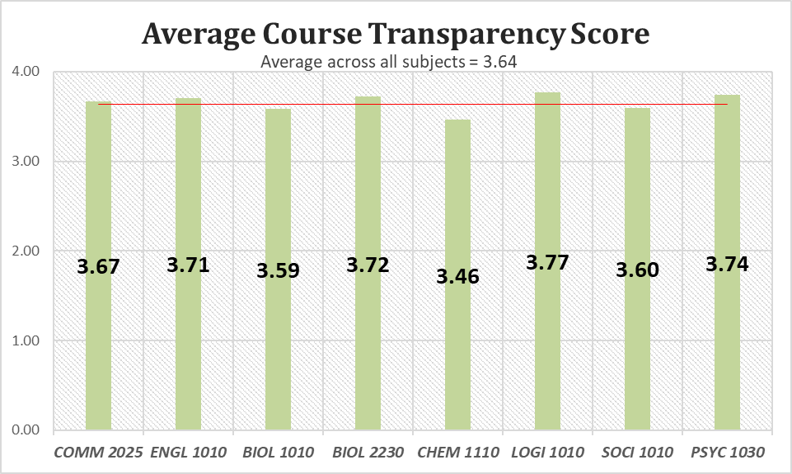

**CONCLUSIONS**

Overall, there appears to be transparency in instruction across all courses with students completing the survey. The one area that did not score well was “My instructor provided students with annotated examples of past students’ work” with 35% responding either ‘Sometimes’ or ‘Never.’